Central 1- Bill Payments

CWB Centralized Services Process Manual

Date Last Updated: Jan 2016

Contents

Overview 5

Limitations 5

CWB’s Central 1 Account 6

BP Transaction Flow 6

Daily Download 7

Description of the Detailed Bill Payment Reports 7

**Bill Payments Remitted – Summary – BPRS Report** 8

**Bill Payments – Remitted – BPRE Report** 8

**Bill Payments – Remitted By Trace – BPTR Report** 8

**Bill Payments – Tracing Report by CU Branch & Vendor – BPCV Report** 9

**Bill Payments – Rejected Transactions – BPRT Report** 9

**Bill Payments – Future Dated** Rejected **Transactions – BPRF Report** 9

**Bill Payments – Cancelled Future Dated Transactions – BPFC Report** 10

**Bill Payments – Daily Maintenance Update – BPMU Reports** 10

How to Download the Daily Central 1 Report 10

Report Requirements 11

Comparison Reports🡪 12

**Bill Payments Not Posted Report** 12

Bill Payments Posted Not Remitted by Central 1 Report 13

Central 1 Account Statement 14

**Example of the Central 1 Account Statement** 14

Central 1 Reconciliation Overview: 15

Settlement & Reconciliation Process Flow 15

Reconciliation Spreadsheet Overview: 18

TAB#1🡪 Bill Payments 18

Managing the Float 18

TAB#2🡪 Wire Settlement 19

TAB#3🡪 Corrections Form 20

TAB#4🡪 Bank & LOC Charges 20

Settlement Overview 20

Managing the Required Float 21

Reports & Spreadsheet Required for Determination & Completion of Settlement 23

Settlement Procedures 23

Example 25

Reconciliation Procedures 26

Reconciliation Procedures: 27

Preparing & Transferring the Settlement Amount - 27

Reconciling CAD1028200011001 28

Reconciling CAD1027000011001 28

Example🡪 Completed Internal Account Reconciliation 30

Corrections & Banking/LOC Charges Overview 32

Posting Correction Entries 32

Reports Required 32

Spreadsheet Used: 33

Preparing the Correction Entries: 33

Posting Banking & LOC Charges: 33

Reports Used: 33

Spreadsheet Used: 34

Examples of Source Data and the Correction & Banking & LOC Charges Forms 34

Branch Notifications 37

How to Notify the Branches of Failed Bill Payments 38

BPRT Report – Rejected Bill Payments 38

BPRF Report – Future-Dated Rejected Bill Payments 38

Administrative Options 39

Example of BPRT & BPRF & BPFC Reports Used to Notify Branches 39

Returned Bill Payments – Initiated & Returned by the Vendor 40

Process 40

Example of a Vendor Initiated Return Report 41

CWB – Central 1 Transaction Response Codes 42

Examples of Transaction Response Codes on the Central 1 Reports 44

Traces, Recalls & Same Day Reversals 45

Service Charges for Client & Vendor Initiated Traces / Recalls & Same Day Reversals 46

Types of Traces 46

OLT – Online Tracing Website 46

OLT – On Line Tracing User Types 46

Client Initiated Traces 49

Completing Trace Details Form 52

Approving a Trace Request – Super Tracers Only 55

Approval Screen 56

Retrieving Trace Information for Settlement Values on the Central 1 Statement 59

How to Retrieve the List of Closed – Settled Traces Report 59

Vendor Initiated Traces / Returns 62

Processing a Vendor Initiated Trace / Return 63

Same Day Reversal 64

Obtaining a Biller Number 72

CWB VISA Bill Payment Traces 73

Overview 73

Process 74

Online Payments Made at Other FI’s 74

Online Payments made by CWB Clients Using CWB Direct 74

Putting the Reconciliation Together 75

BP Tracking Volumes 76

Verifying Monthly Billing for Traces 77

Verifying & Matching Charges 77

Extracting the Monthly List of Closed – Settled Traces 78

Sample Reports 79

Monthly Charge Report 79

List of Closed – Settled Traces 🡪 CWB Initiated & Vendor Initiated Billing Summary 80

Details by Trace – CWB Initiated 80

Details by Trace – Vendor Initiated 80

Service Charges Log – Same Day Reversals 81

Summary of Bill Payment Settlement & Reconciliation Process 82

Part A – Report Gathering 82

Part B – Verifying Statement Details 82

Part C – Wire Settlement 82

Part D – Reconciling the GL’s 83

Part E – Rejected Transactions 84

Part F – Tracking 84

Part G – Putting the Reconciliation Together 85

FAQ’s- Miscellaneous Problem Solving 85

Further Explanations of System Issues 85

Examples of Delayed Remittance Vendors 86

Alternate Report Options 86

Trouble Shooting Issues 86

Central 1 Contacts 87

# Overview

CWB’s online Bill Payment service is provided by Central 1 (C1) located in BC. Central 1 will gather and remit CWB’s clients’ bill payments on CWB’s behalf. CWB holds an account with Central 1 specifically designated to settle the bill payment transactions remitted by C1. C1 will debit CWB’s account for the value of the bill payments owing. CWB will settle with C1 by sending an outgoing wire transfer to the CWB account at C1.

* **Settlement must be completed prior to 9:30 AM MT to make CWB’s account with C1 whole again**

CWB clients can make bill payments either through online banking or over the counter at a CWB branch (OTC).

* Personal Clients 🡺 CWB Direct
* Business Clients 🡺 CWB Direct **OR** CWB Business Online Banking

CAP’s primary responsibilities for Bill Payments is to ensure the timely & accurate settlement for the amount owing to C1 for remitted payments as well as the reconciliation of the bill payments reported against the bill payments posted to client accounts by the banking system. CAP must identify the items that were remitted but not posted by the banking system and what payments were posted by the banking system but not remitted by C1.

In order to identify the exceptions, a comparison process is run and a report is generated in the report portal named: CUCBC Exceptions.

* **Reconciliation must be completed no later than 12:00 PM MT in order to allow sufficient time for any action required by the branches**

All BP transaction traces are initiated, executed and managed online via a Central 1 secured website called OLT – Online Tracing. Each admin will be provided with their own user ID & password for access to Online Tracing. Hard copy documentation of all traces is also maintained.

**OLT – Online Tracing URL** - <https://www.secure.central1.com/Pages/Applications.aspx>

The correct term for this online product is CWBDirect Bill Payments but is also known as Direct Pay or simply Bill payments.

## Limitations

**Duplicate Payments** 🡪 A BP initiated by a CWB client on the same day, from the same account – regardless of which prefix the BP was generated from – for the same amount, to the same vendor will be rejected by C1 automated system and will not be remitted to the vendor. The reason for this precaution is to prevent erroneous duplications.

The **maximum** bill payment amount allowed per transaction is **$350,000.00**. If a client wishes to make a payment for an amount greater than this, they are to split the payment into ***two different amounts***. If the amounts of the payments are the same, Central 1 will reject the second payment as a duplicate.

Every successfully submitted BP 🡪 payable current day or future-dated 🡪 will generate a 6 digit confirmation # confirming completion of submission. This confirmation # does not imply the payment was remitted but only that the request has been successfully submitted to & received by Central 1.

CWBDirect Online Bill Payments is available 24 hours a day, 7 days a week, all year round via online banking

## CWB’s Central 1 Account

What do you need to know about the CWB account held at Central?

* The account is to be used exclusively for the settlement of online bill payments remitted by C1 on CWB’s behalf
* C1 & CWB will settle daily – on Monday, there will be separate transactions for the settlements due for Friday, Saturday & Sunday – CWB will send one settlement for the 3 days
* C1 will credit the account for any traces or returned bill payments
* CWB holds a Line of Credit with Central 1 in order to accommodate the potential settlement overdraft of the account
* C1 will notify the CAP Managers when CWB has reached 65% of its capacity allowing CAP Deposits to settle outside of the daily process and prevent service disruption
* CWB must maintain a minimum float in the C1 account as determined by business requirements & Central 1
* The current float is set at $5 million but should be adjusted accordingly

**The CWB account at C1 must be maintained at a minimum balance as determined by business needs and C1 requirements. Currently, the minimum balance or float required in the Bill Payments account is $5 million Monday thru Thursday & and additional $1.5 million for each weekend date on Friday. For any holidays, an additional $1.5 million will be required for each holiday date. The CWB account must balance to a net of the float on a daily basis.**



**Example of float requirements for a long weekend:**

**$5,000,000 (base) + $1,500,000 (Sat) +$1,500,000.00 (Sun) + $1,500,000 (holiday Mon) = $9,500,000.00 to be included in the settlement generated on Friday.**

**CWB’s account # with Central 1 – 080968850 held at FI # 0809 Transit # 12010**

## BP Transaction Flow

When a client processes an online bill payment the following actions take place:

1. *A real-time API call is generated from C1 to CWB’s banking system – API stands for Application Interface & is the means by which the CWB banking system and the C1 banking system communicate. The API call is an electronic file of information sent individually for each transaction generated*
2. *The banking system will check the clients account for messages & the availability of funds*
3. *If the banking system approves the transaction:*
   1. *CWB responds to C1’s API call authorizing the bill payment*
   2. *Client account is debited by either:*
      1. *ACMB transaction type (Online Bill Payment)*
      2. *OTC transaction type (OTC Bill Payment)*
   3. *Posted by CWBDirect Tellers:*
      1. MDI.USER__OFS_MDI (System Teller for CDF client Online Bill Payments)
      2. MDI.USER__OFS_MDO (System Teller for CWB client CWBDirect Bill Payments)
      3. MDI.USER__OFS_MDB (System Teller for CWB client CWB Business Online Bill Payments)
      4. EBILL.USER.1__OFS_EBILL.SRC (System Teller for CDF Client Future Dated Online Bill Payments)
      5. TELLERNAME.X__OFS_BROWSERTC (OTC Bill Payment Made in Branch)
      6. OFS.USER__OFS_EBILL.SRC.1 (OTC Future Dated Bill Payment Made in Branch)
   4. *Offset internal account CAD1027000011001 is credited*
   5. The BP is held at C1 & remitted to the individual vendors on the following business day
4. *If the banking system rejects the request:*
   1. *CWB banking system responds to C1’s API call but does not authorize the bill payment*
   2. *Central 1 returns an error message to the client indicating that the BP could not be processed*
   3. *Client’s account is not affected & the bill payment is not remitted by C1*

Daily Download

The service provider – Central 1 – creates a report detailing all bill payments received from CWB clients. The report is generated on a daily basis and is made available to CWB thru a secured FTP site. CWB CAP downloads & transfers the report from C1’s FTP site to CWB’s Network using a program called **WS_FTP Pro**.

The filename of the Central 1 Report is **BILLMMDD.DAT –** the date is embedded in the name of each bill payment report: the date embedded in the report name is one day greater than the date to be reconciled. The Bill Payments report from Central 1 is essential & key in the settlement & reconciliation process.

***For example: BILL0822.DAT contains data for August 21***

* C1 will produce a BILLMMDD.DAT report for each day of the year
* CWB’s retention of the BILLMMDD.dat files is 10 years and is archived annually by a manager

**Description of the Detailed Bill Payment Reports**

The BILLMMDD.dat report is made up of several different reports. Some reports are used to complete the settlement, reconciling and notification processes. Others reports are valuable & informative reports and can be used for enquiries, traces and investigations.

**Bill Payments Remitted – Summary – BPRS Report**

* Summarizes the number and the total dollar value of the remitted bill payments from the previous day
* Report is broken down by Electronic Items & Tax Payment Items
* This report can be used as a source to verify the value of the transactions debited to CWB’s account
* This report can be used to determine the settlement amount owing if the CWB Central 1 account statement is unavailable or not up-to-date

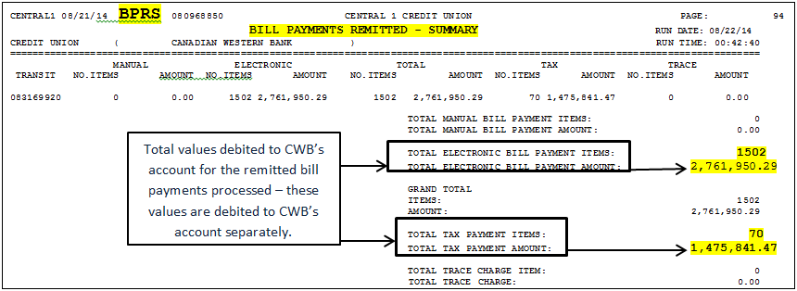

**Bill Payments – Remitted – BPRE Report**

* Lists the remitted bill payments in client account number order with detail
* The **BPRE** also ends with a summary of payments at the conclusion of the report
* Report is the **primary source** for C1 data used by the CUCBC Access program to generate the comparison reports
* **Critical** in the reconciliation process

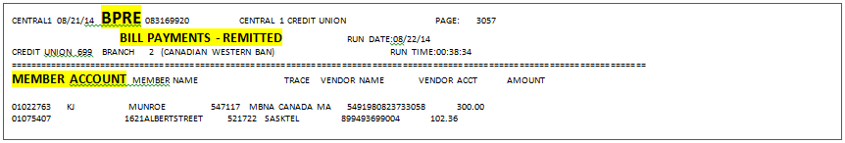

**Bill Payments – Remitted By Trace – BPTR Report**

* Lists the remitted bill payments in trace number order with detail
  + The **BPTR** also ends with a summary of payments at the conclusion of the report
  + Not used in the reconciliation process but can be a source of information for traces & client enquiries

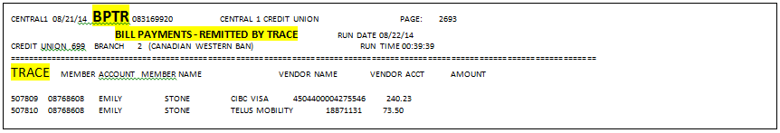

**Bill Payments – Tracing Report by CU Branch & Vendor – BPCV Report**

* Lists the remitted bill payments in time order broken down and totalled by vendor in detail including transaction acceptance / completion time
* The **BPCV** is totaled by each vendor with a summary of total payments remitted to each vendor
* The time reported is Pacific time
* Not used in the reconciliation process but can be a source of information for traces & client enquiries

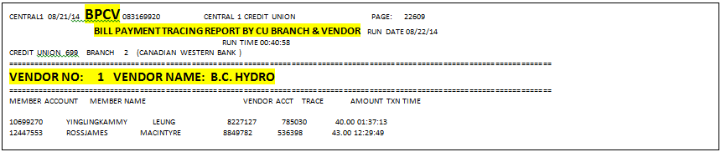

**Bill Payments – Rejected Transactions – BPRT Report**

* Lists the transactions that Central 1 received then rejected and did not remit in account number order with details
  + **Reversed By User** includes:
    - Same Day Reversals requested by CWB & processed by C1
    - Transactions rejected by the banking system
  + **Rejected Items** – Transactions rejected at Central 1 🡪 Refer to CWB – Central 1 Transaction Response Codes
* This report is ***essential*** in the reconciliation process
* The BPRT is totaled with a summary of payments rejected or reversed
* The time reported is Pacific time
* The items listed are *current day transactions* that were initiated, executed & rejected current day

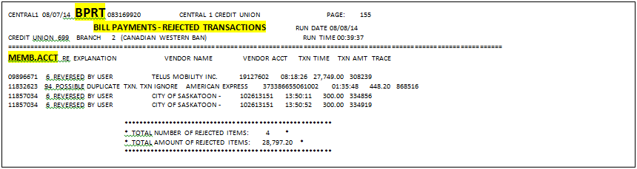

**Bill Payments – Future Dated** Rejected **Transactions – BPRF Report**

* Lists the transactions that were set up on a date in the past by a CWB client, but rejected on the future dated pay date in detail including the reason for rejection 🡪 Refer to CWB – Central 1 Transaction Response Codes
* This report is ***essential*** in the notification to the branches and clients but not used in the reconciliation process
* Includes the **Original TXN Date** – the original date the future-dated bill payment was set up by a CWB client
* The **BPRF** is totaled with a summary of payments rejected
* The items listed are transactions that were initiated in the past for a future-date but executed & rejected current day
* Once CAP notifies the branch(es), the client is then notified – it is the only means of notification the client receives that their payment was not processed
* *T****his report is critical*** to the notification process

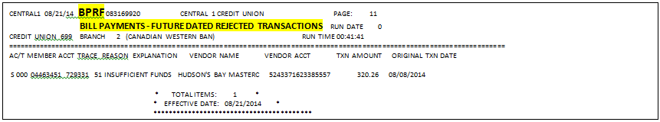

**Bill Payments – Cancelled Future Dated Transactions – BPFC Report**

* Lists the transactions in detail, that were set up in the past to be paid on a future date, but cancelled by the client on the current date
* Not used in the settlement, reconciliation or notification process but is a possible source of information for traces & client enquiries
* The **BPFC** is totaled with a summary of future dated payments cancelled by clients

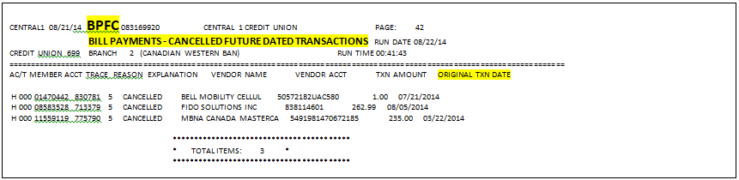

**Bill Payments – Daily Maintenance Update – BPMU Reports**

* Reports the additions, deletions & changes the CWB clients have made to their bill payment vendor list
* Not used in the settlement, reconciliation or notification process but is a possible source of information for traces & client enquiries
* The **BPMU** is totaled with a summary of updated vendor records

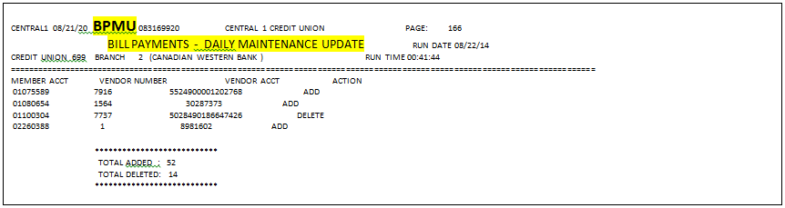

**How to Download the Daily Central 1 Report**

* See Job Aid: “How to Download the Central 1 Report🡪 BILLMMDD.dat”

Report Requirements

Various reports from several sources are required in order to complete settlement, reconciliation and branch notification processes.

Gather & print the following reports:

1. **From Central 1 BILLMMDD.dat report**
   * BPRT – Rejected transactions
   * BPRF – Rejected future dated transactions
   * BPFC – Cancelled future dated transactions
2. **From the Report Portal– CUCBC Exception Report**

* Remitted Bill Payments Not Posted
* Bill Payments Posted Not Remitted by Central 1

1. **CWB Central 1 Account**

* Account Statement – 2 copies

|  |  |  |  |
| --- | --- | --- | --- |
| Report Name | Required for | Report Sourced From | Purpose of Report |
| BPRT – Rejected Transactions | * **Reconciliation** * **Notification** | Central 1 – **BILLMMDD.dat** | * Isolates payments that were not remitted by C1 * ***Rejected*** items are carried as ***reconciling*** items * Identifies the clients to be corrected * Used to ***notify*** the branches of the client rejects |
| BPRF – Rejected Future Dated Transactions | * **Notification** | Central 1 – **BILLMMDD.dat** | * Isolates future dated payments not authorized by CWB & therefore not remitted * Used to ***notify*** the branches of the client rejects |
| BPFC – Cancelled Future Dated Transactions | * **Information Only** | Central 1 – **BILLMMDD.dat** | * Reports the future dated transactions cancelled by the clients * For information purposes only |
| Remitted Bill Payments Not Posted | * **Settlement** * **Reconciliation** | **Report Portal** | * A comparison of items remitted by Central 1 that **were not posted** by the banking system * Critical for completing **settlement** * Critical for completing **reconciliations** |
| Bill Payments Posted Not Remitted by Central 1 | * **Reconciliation** | **Report Portal** | * A comparison of items posted by the banking system but **not remitted** by Central 1 * Critical for completing **reconciliations** * Critical for completing **branch notifications** |
| CWB Central 1 Account Statement | * **Settlement** * **Reconciliation** | **Online C1 Banking** URL – each manager has access to the account via online banking to print account statements | * Statement lists the transactions from the previous day * All debits for remitted payments * All credits for traces, recalls, refunds * All deposits for the previous day’s wire settlement * Critical for completing **settlement** |

**Central 1 BILLMMDD.dat Reports**

Previously, in the daily download step, the BILLMMDD.dat report was copied and saved to: G:\ Direct Pay \ BC CENTRAL REPORTS \ YYYY \ MMM

1. Open the BILLMMDD.dat report using Microsoft Word
2. Run the HOBS macro by pressing **ALT** 🡪 **F8** 🡪 **Run**
3. **Go to** the **BPRT** Report 🡪 use the **Find** function & look for **BPRT**
4. **Print** the **BPRT** report
5. **Go to** the **BPRF** Report 🡪 use the **Find** function & look for **BPRF**
6. **Print** the **BPRF** report
7. **Go to** the **BPFC** Report 🡪 use the **Find** function & look for **BPFC**
8. **Print** the **BPFC** report
9. Do not close the report
10. Save the report in the required location for the Access CUCBC.mdb program to retrieve and ingest
11. Name the file ***directpay.txt***
12. **File** 🡪 **Save As** 🡪 **N:\ MISCommon \ CAP \ Day of Week (Monthend) \ directpay.txt**
13. Since the document is saved every day continue by over-writing the old file with the new file
14. Click **🡪 Okay 🡪 Okay 🡪 Replace Existing File**

**Comparison Reports🡪**

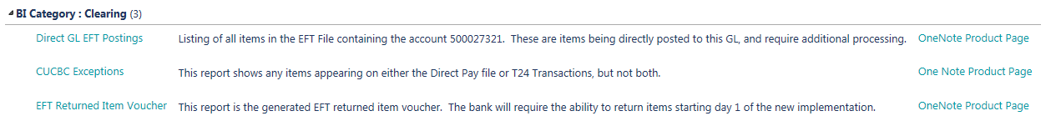

**Bill Payments Not Posted Report**

* The transactions listed on this report were ***remitted*** by Central 1 on the reconciliation date but are not reporting as posted on the banking system report 1 transactions
* The report is sorted in remitted time ascending order
* All the transactions being reported were remitted by Central 1 on the previous day during the CWB banking system overnight process when the banking system was not available to post transactions. These transactions will report on the ***Bill Payments Posted Not Remitted by Central 1*** report the ***next day*** and can be compared if necessary.
* ***For example*** 🡪 on ***Monday***, between the hours of approximately 10 PM & midnight the overnight process (COB) is being run; therefore, the banking system is not available to post BP transactions to client accounts however, Central 1 will still accept, process & remit any bill payments initiated by CWB clients
* On ***Tuesday*** morning, immediately after the overnight process (COB) has been completed, the transactions that were held back because of the overnight process will now be posted
* On ***Tuesday***, CAP will reconcile ***Monday’s*** BP transactions
* On **Tuesday**, the ***Remitted Bill Payments Not Posted*** for Monday’s reconciliation will report all the transactions that took place during the 10 PM & midnight time period on ***Monday*** night that were remitted but not posted on ***Monday***
* On ***Wednesday****,* CAP will reconcile ***Tuesday***
* On ***Wednesday***, the ***Bill Payments Posted Not Remitted by Central 1*** for ***Tuesday*** will report all the same transactions that were reported on the ***Remitted Bill Payments Not Posted*** on ***Tuesday* *for Monday*** but now they are reporting as posted & not remitted by Central 1
* ***To Compare 🡪*** Use the ***Remitted Bill Payments Not Posted*** from Monday’s reconciliation & cross-tick to compare these transactions to the ***Bill Payments Posted Not Remitted by Central 1*** from Tuesday’s reconciliation.
* The timeframe when the banking system is not available is known as ***“Rights-Off”***
* The transactions listed should have a remitted time within the rights-off time frame
* If the time reported is not within the rights-off time frame investigate to determine the reasons:

**Either:**

1. The transaction was posted on a previous date but is payable to a vendor which requires 2 processing days – this is known as a ***Delayed Remittance*** and the item is okay- see examples of ***Delayed Remittances Vendors*** below
2. The transaction did not post at all – this is not okay & will require attention

**On a daily basis, the Remitted Bill Payments Not Posted report must be reviewed for transactions with a time that does not meet the time slot for Rights-Off. If the transaction cannot be allocated to a Delayed Remittance, then investigate the client account to ensure the banking system has posted the transaction. If the banking system has not posted the item, then you must post the transaction with an effective date equal to the original transaction date.**



* This report is used to post the settlement transfer🡪 use the **Grand Totals**
* This report isolates transactions to be used as reconciling items for internal account CAD1027000011001 🡪 **far right Total** of remitted items not yet posted

Total of Remitted Bill Payments Not Posted



**Bill Payments Posted Not Remitted by Central 1 Report**

* The transactions listed on this report were posted by the banking system on the reconciliation date but are not reporting as remitted on the Central 1 BILLMMDD.dat file of the same date
* The report is sorted in posting time ascending order
* All the transactions posted with a time within the first 2 – 3 hours after midnight is a transaction remitted by Central 1 during the previous day’s overnight process when the banking system was not available to post. These transactions would have reported on the Remitted Bill Payments Not Posted report from 2 days back and can be compared if necessary. See example above
* The timeframe when the banking system is not available is known as ***“Rights-Off”***
* The transactions listed after the previous days’ rights-off postings have a posting time later in the day & are not remitted by Central 1 for one of three reasons:
  + The payment is a rejected item listed on the BPRT Report therefore not remitted however, the banking system will have posted it🡪 **rejects are reconciling items**
  + The payment has not yet been remitted by Central 1 – some vendors require 2 processing days🡪 **Delayed Remittances are reconciling items**
  + The transaction was a Same Day Reversal that was posted but was pulled from the “to be paid” queue as instructed by CAP🡪 reversed items are **not reconciling items**
* This report is used to isolate transactions to be used as reconciling items for internal account CAD1027000011001

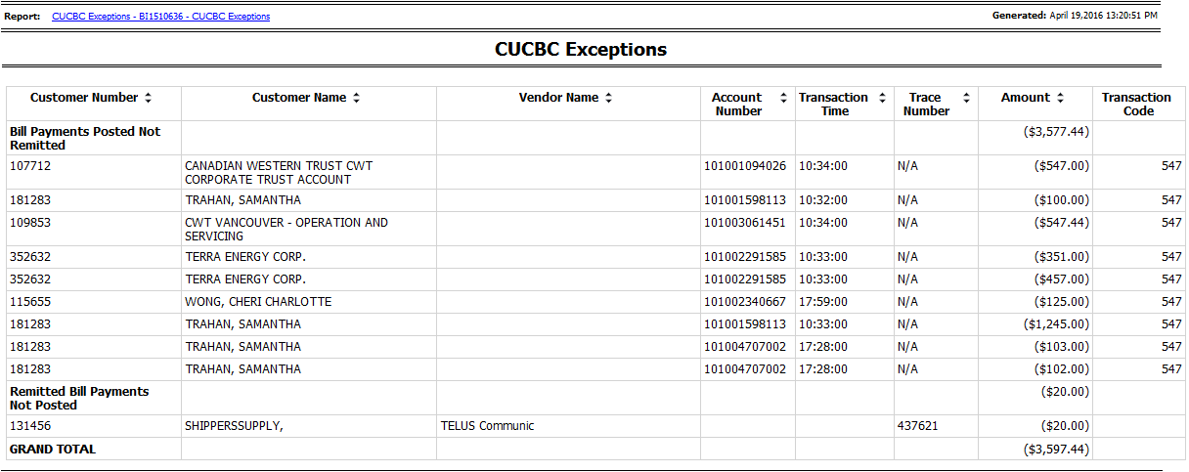

Total

Total

**Central 1 Account Statement**

* All CAP Corp Managers have access to the CWB account held at Central 1 thru CBS Online
* CBS Online is the Central Banking System Online access for Central 1 clients
* A manager will print 2 copies of the account statement
* The statement must be date-ranged to include transactions from the previous day as well as show the account balance netting to the value of the current float
* The URL to access Central 1 online banking is🡪 <https://business.memberdirect.net/business/default.jsp?inst=/bus/central1/&app=Business>

**Example of the Central 1 Account Statement**

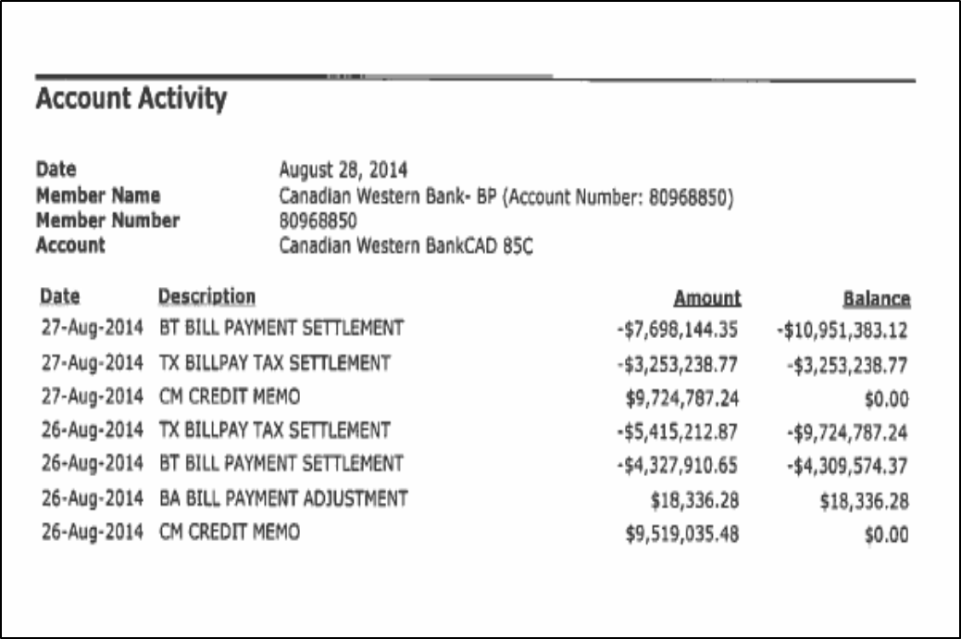

This transaction indicates a refund or funds for an incoming trace

This transaction shows the previous day’s settlement- the account must be at the float value once settlement is rec’d

These are the new BP’s charged to CWB’s account for yesterdays remitted items

New amount owing to C1

Central 1 Reconciliation Overview:

The spreadsheet used to complete the reconciliation and settlement of the Central 1 account is called “Central 1 Reconciliation- Direct Pay”. The spreadsheet can be located in: G:\Direct Pay🡪 Central 1 Reconciliation- Direct Pay

The spreadsheet has 4 tabs:

1. Bill Payments 🡪 where the daily settlement & reconciliation functions are performed
2. Wire Settlement 🡪 where the wire posting & documentation is generated
3. Corrections Form 🡪 where data is entered & transactions are generated for corrections and adjustments
4. Banking & LOC Charges 🡪 where data is entered & transactions are generated for yearly LOC charges & monthly services charges

## Settlement & Reconciliation Process Flow

# Reconciliation Spreadsheet Overview:

## TAB#1🡪 Bill Payments

There are 4 sections to the spreadsheet:

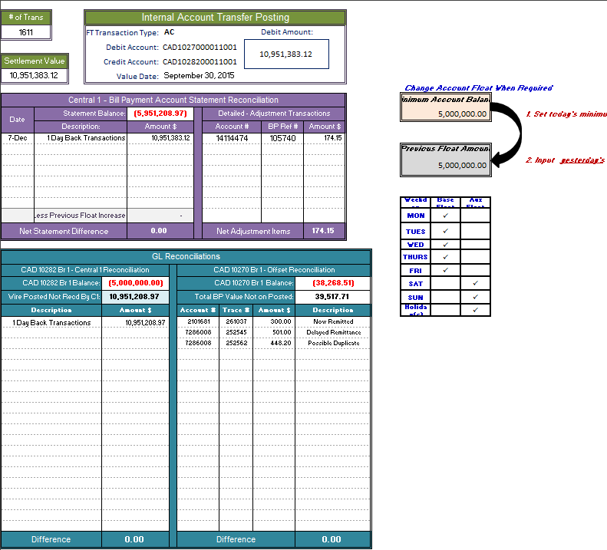

These are the cells utilized in managing the float!

Green Section🡪 Internal Account Transfer

* Used to post the daily remittance

Teal Section🡪 Internal Account Reconciliation

* Used to reconcile the internal accounts
  + CAD1028200011001
  + CAD1027000011001

Purple Section🡪 Central 1 Statement Rec

* Used to determine settlement

### Managing the Float

* The float amount can be adjusted whenever required
* The cell containing the float amount is included in all calculations within the reconciliation
* Once the float in the top cell has been adjusted, the bottom cell must be updated with the previous float amount
* All formulas containing the float amount will be updated as well
* The correct float amount is required in order to send the correct wire value for settlement
* The correct float amount is required in order to reconcile

**If ever the float value is changed – increased or decreased – simply change the float amount prior to completing the settlement or reconciling the GL’s**



## TAB#2🡪 Wire Settlement

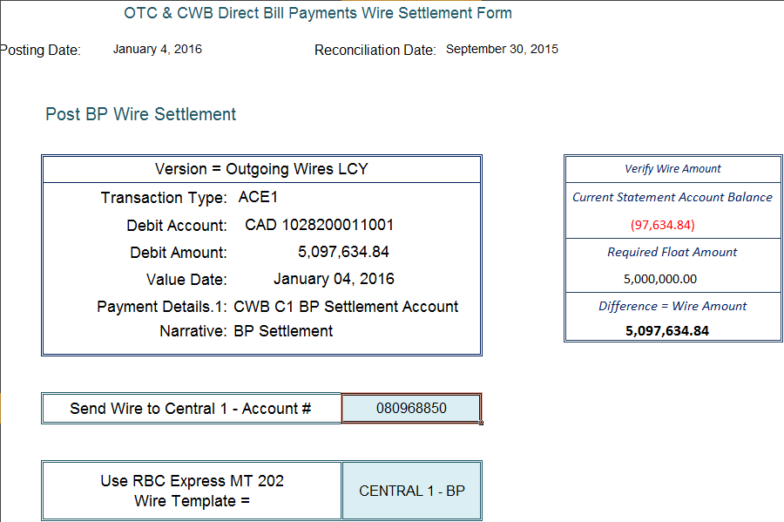

Wire template used on RBC Express

Posting for wire settlement and wire settlement amount

Settlement value is dependent on remittances + float value

## TAB#3🡪 Corrections Form

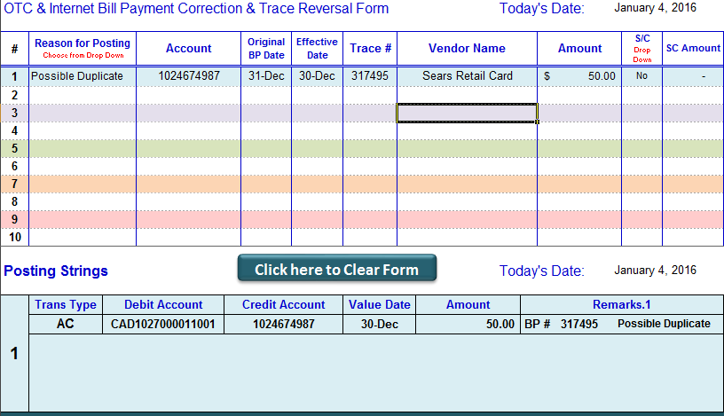

Input of transaction information

Automated generation of transaction posting entry

## TAB#4🡪 Bank & LOC Charges

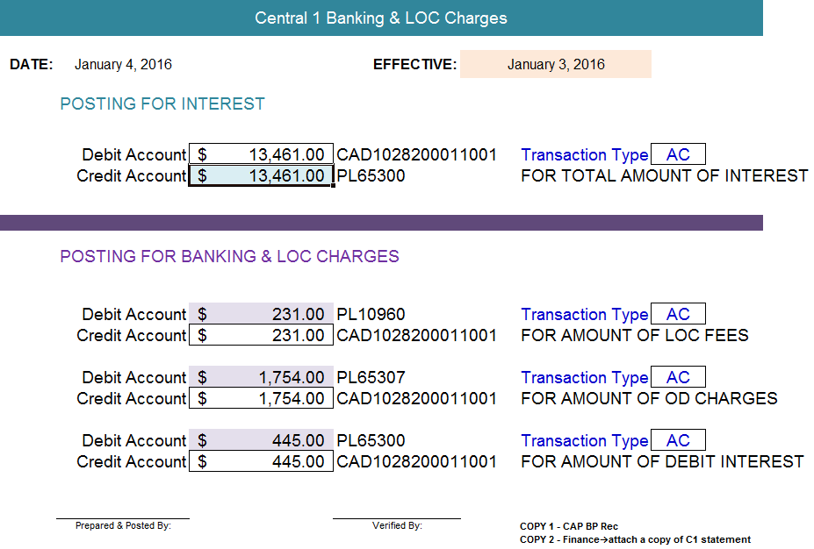

When bank or LOC charges are included on the account statement, the data is entered to create an entry🡪 the resulting entry is posted

When interest is included on the account statement, the data is entered to create an entry🡪 the resulting entry is posted.

* In all cases, a copy of the entries are sent to Finance along with a copy of the account statement

# Settlement Overview

Settlement to Central 1 is completed daily. Once a settlement amount is determined, an outgoing wire is initiated and sent to Central 1. Settlement is the first task to be completed and has a **deadline of 9:30 AM MT.**

Completing settlement consists of:

* Balancing the CWB Account Statement
* Posting & creating an outgoing wire
* Adjustment of account float value

The settlement amount owing will consists of:

* Successfully remitted bill payments from the previous day 🡪 Debit to CWB C1 account
* Trace Refunds for completed recalls initiated by CWB 🡪 Credit to CWB account
* Returned Funds for invalid payments initiated by the vendor 🡪 Credit to CWB account
* Possible additional float funds 🡪 Credit to CWB account

Debits for remitted payments occur daily

Credits for traces and refunds are not a daily occurrence

**When float value is changed – increased or decreased – simply change the float amount prior to completing the settlement or reconciling the GL’s**



## Managing the Required Float

* The minimum required float for the Centra1 account must be managed on a daily basis
* The minimum required float for the weekdays will be different than the required float for any non-business days such as weekends or holidays
* The current base float amount is $5 million
* The current auxiliary float amount is an additional $1.5 million ***for each non-business day between working business days***

***For example****🡪 On Friday, the Float value would be increased to $8 million therefore this value would be input into the top cell. The cell for the previous float amount would remain at $5 million.*

*🡪 On Monday, the Float value would be decreased to $5 million therefore this value would be input into the top cell. The cell for the previous float amount would now be input at $8 million because that is what the float was set to on the last working day.*

**Account Float Adjustment Table**

|  |  |  |  |  |  |
| --- | --- | --- | --- | --- | --- |
| Float Reference | Mon | Tues | Wed | Thurs | Fri |
| Today’s Cell | 5,000,000 | 5,000,000 | 5,000,000 | 5,000,000 | 8,000,000 |
| Previous Day’s Cell | 8,000,000 | 5,000,000 | 5,000,000 | 5,000,000 | 5,000,000 |

|  |  |  |
| --- | --- | --- |
| Float Reference | Day Before a Holiday | Day After a Holiday |
| Today’s Cell | **5,000,000 + (1,500,000 X # of Days)** | **5,000,000** |
| Previous Day’s Cell | **5,000,000** | **5,000,000 + (1,500,000 X # of Days)** |

***The float is managed in the Minimum Account Balance field & must be updated prior to the completion of the settlement calculation & generation of the settlement wire***

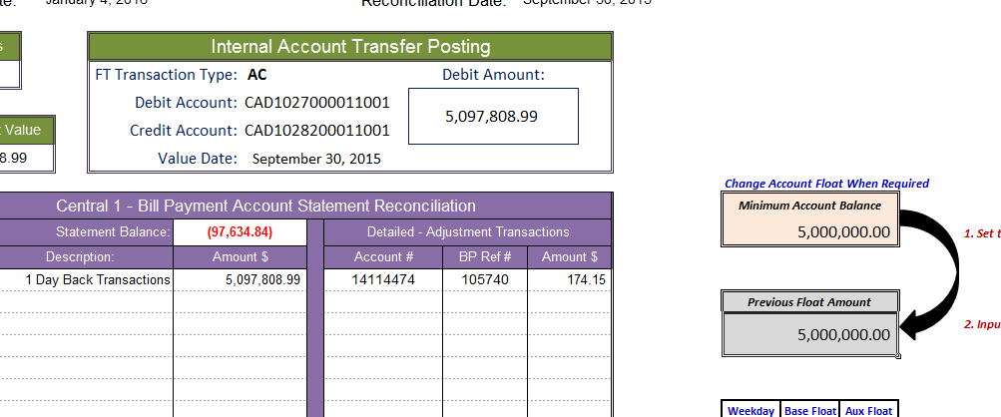

Cell 2

Cell 1

* *The top cell – Cell 1 - must contain the value of today’s minimum float*
* *The bottom cell – Cell 2 - must contain the value of the previous day’s float*
* *Step One* 🡪 *Input today’s Float amount*
* *Step Two* 🡪 *Input the previous Day’s Float amount*

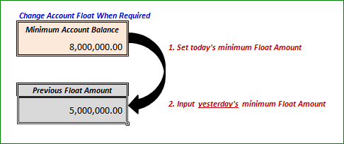

Increase Float🡪 Friday’s Reconciliation

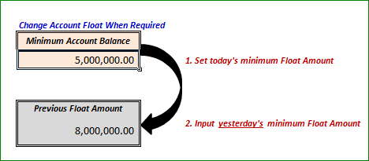

Decrease Float🡪 Monday’s Reconciliation

Reports & Spreadsheet Required for Determination & Completion of Settlement***:***

**Reports used:**

* CWB Account statement
* Remitted Bill Payments Not Posted

**Reconciliation Spreadsheets used:**

* Central 1 Reconciliation – Direct Pay 🡪 **tabs # 1 & 2**
* **Tab # 1** – Bill Payments 🡪 Purple section 🡪 Central 1 – Bill Payment Account Statement Reconciliation
* **Tab # 2 –** Wire Settlement 🡪 CWB Direct

Bill Payments Wire Settlement Form

## Settlement Procedures

1. Open the reconciliation spreadsheet
2. Select the first tab on the far left – **Bill Payments**
3. Change the reconciliation date to reflect the date to be reconciled
4. Using the CWB account statement, check to ensure the statement activity 🡪
   1. Netted to the float value for the previous day
   2. Includes all the settlement amounts owing for the previous day(s)
      1. **Hint –** the statement end balance must be equal to the sum of each BPRS Summary or the sum of each Grand Total owing plus Settled Traces & Returned Funds plus the float value
   3. After a weekend or holiday, the statement end balance will include the totals owing for any day that CWB has not yet settled
   4. If any settlement amounts owing are not included in the statement activity, an alternate report or reports must be used to complete the settlement process 🡪 such as the BPRS Summary or the sum of each Grand Total
   5. If the statement activity includes the required transactions, then continue with step 5
   6. If the statement activity does not include the required transactions, then choose an alternate source to determine a settlement amount 🡪 see Alternate Report Options
5. Enter the statement end balance in the ***Statement Balance*** field 🡪 Since the float value may cover the settlement values, the end balance could be either a ***positive*** or a ***negative value***
6. Using the Remitted Bill Payments Not Posted, locate the ***Grand Totals*** on the last page
   1. After a weekend or holiday, there should be a Grand Total for each day to be reconciled
7. Enter each day’s Grand Total 🡪 for each day’s amount owing enter the following:
   1. The date
   2. The description from the drop down options
   3. The total amount owing
8. Once the Grand Totals have been entered, the ***Net Statement Balance*** should be at zero
9. If the statement includes a credit for a refund or recalled trace, enter the details in the right-hand side of the purple section:
   1. Account #
   2. BP Ref #
   3. Amount $
   4. If the credit is made up of multiple refunds, the details for each refund must be added to the spreadsheet separately – see example below
10. Instructions for retrieving the details for Settled Traces & returned funds can be found at Retrieving Trace Information for Settlement Values
11. Once each Grand Total & trace detail amounts have been entered, the ***Net Statement Difference*** should be zero

### Example

Account Statement:

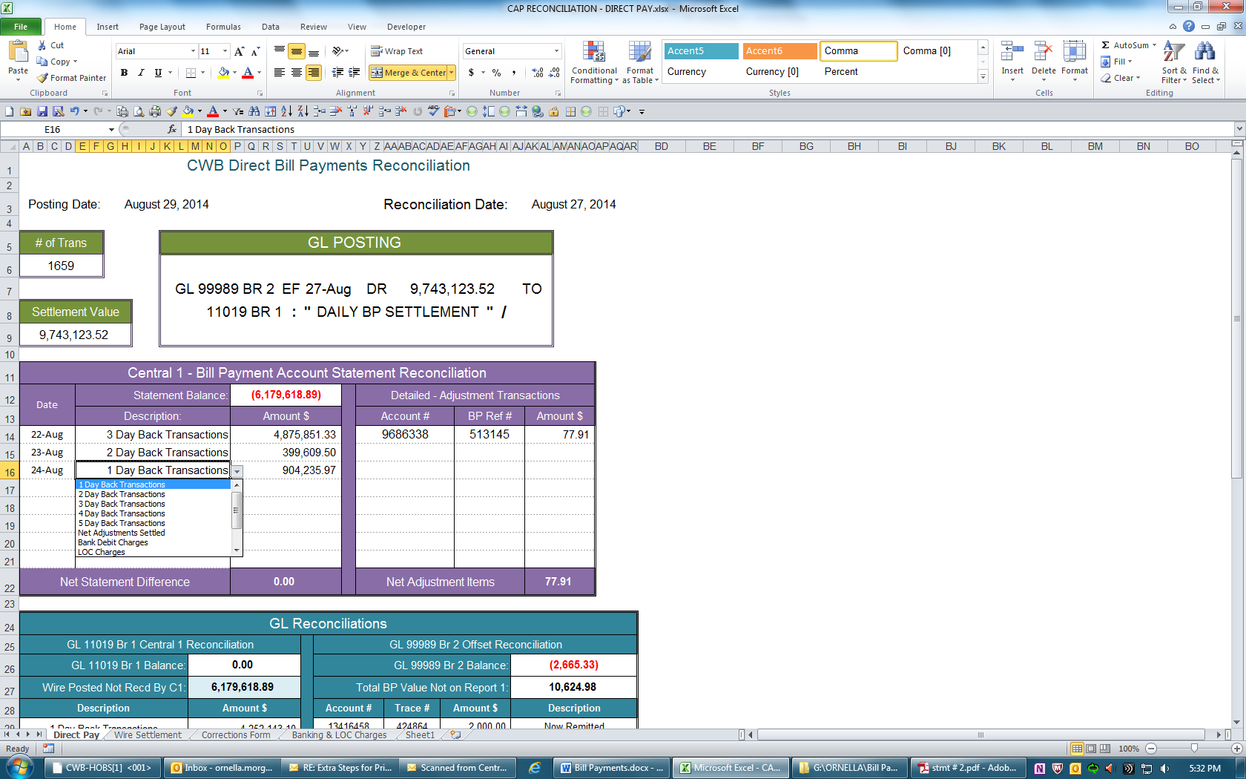Reconciliation Spreadsheet:

Adjustments received

Amounts Owing

Dates

Net Adjusted Items must always be equal to the credit posted to the statement

Drop Down Options

1. Select the second tab – **Wire Settlement**
2. This tab links into the first tab & generates the wire settlement posting
3. This tab provides the backup to create the settlement wire
4. **Print** the Wire Settlement tab
5. **Post** the wire settlement transaction generated
   1. Posting the outgoing wire settlement debits the amount of the settlement from the settlement internal account CAD1028200011001 and credits the outgoing wire internal account CAD1011100011001
   2. The posting is effective dated today
   3. A quotation is required & is already included in the wire posting
6. Using **RBC Express SWIFT Payments**, create a wire
   1. Use the **MT 202 template** indicated on the form called 🡪 ***CENTRAL 1 – BP***
   2. The wire value must be same value as the wire settlement posting & the end balance on the CWB account statement 🡪 all three values must be the same
7. Print the wire pending approval from RBC Express
8. Gather & initial the following pages & hand in to a supervisor for authorization
   1. The Wire Settlement page from spreadsheet (TAB #2)
   2. The account statement
   3. The wire printed from RBC Express
9. The wire settlement procedures are now complete

## Reconciliation Procedures

Once the wire settlement has been sent, the next step is to complete the reconciliation processes for:

* Settlement internal account 🡪 CAD1028200011001
* Offset Suspense internal account 🡪 CAD1027000011001

|  |  |
| --- | --- |
| ***Reports & Spreadsheet Sections Required:***  **Reports used:**   * CWB Account statement * Any Outstanding Traces now settled * **BPRT** Report * Remitted Bill Payments Not Posted * Bill Payments Posted Not Remitted by Central 1 * CAD1028200011001 print out * CAD1027000011001 print out | **Reconciliation Spreadsheet Sections Used:**   * GL Posting 🡪 use green section * CAD1028200011001 🡪 use teal section 🡪 left side * CAD1027000011001 🡪 use teal section 🡪 right side |

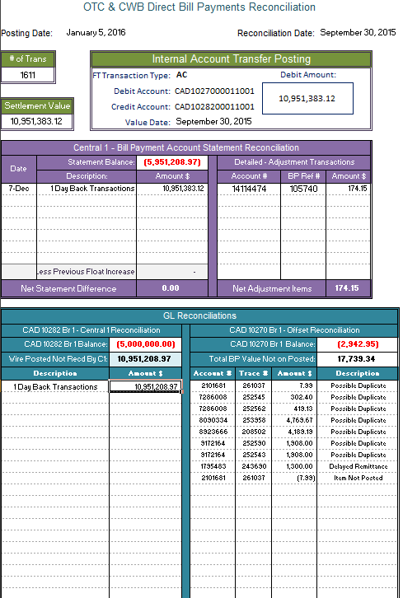

CAD10282

CAD10270

Green Section🡪 Used for posting the daily remittance

Teal Section🡪 Used for reconciling the internal accounts

* CAD1028200011001🡪 Left Side
* CAD1027000011001🡪 Right Side

Purple Section🡪 Already completed in the settlement process

## Reconciliation Procedures:

### **Preparing & Transferring the Settlement Amount -**

1. Use the first tab – Direct Pay 🡪 Green section
2. Input the information required in order to complete the GL Postings
3. Using the Remitted Bill Payments Not Posted, locate the Grand Totals
4. Enter the number of transactions into the **# of Trans**  cell
5. Enter the value of the remitted transactions into the **Settlement Value**  cell
6. Post the transaction generated in the  **GL Posting**  field
7. Posting this transaction transfers the value of remitted payments from the suspense offset CAD1027000011001 to the settlement CAD1028200011001
   1. The posting is effective dated to the reconciliation date
   2. A quotation is required & is provided in the posting string
8. Print the current GL Balances for –
   1. CAD1027000011001
   2. CAD1028200011001

**Alternate Report Options:**

If the Remitted Bill Payments Not Posted is not available or up-to-date, the totals from each separate **BILLMMDD.dat** report can be used in its place 🡪 ***BPRS – Bill Payments Remitted Summary***

 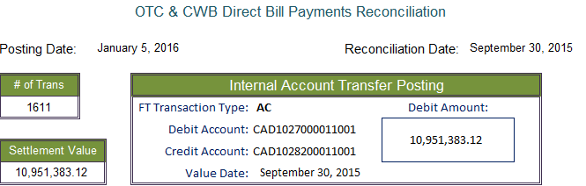

Posting Entry



## Reconciling CAD1028200011001

1. Use the first tab- Bill Payments 🡪 Left side of Teal section
2. Using the internal account print out 🡪 input the CAD1028200011001 end balance **as is** in the cell marked ***CAD10282 BR 1 Balance***
3. The value of the wire posted is automatically carried as part of the reconciliation
4. From the description field 🡪
   1. Choose the description from the drop down menu
   2. Enter the value of the transaction – this is the Grand Total amount posted in step 6
5. At this point, the ***Net Difference*** should be ***zero***
6. If not, eliminate the possibilities & locate the issue 🡪
   1. Review the values input into the spreadsheet
   2. Review the value of the float amount
   3. Review the postings for both the transfer & wire settlement
   4. Are there any Net Adjustments Settled that are now reconciling items
   5. Are there any posting errors from a previous day
   6. Are there any LOC Charges posted that are now reconciling items
   7. Are there any Bank Charges posted that are now reconciling items
   8. Once the issue has been located 🡪
      1. List the differences with the appropriate description from the drop down box or
      2. Correct the posting error & retrieve & input a new CAD1028200011001 balance
7. If CAD10282 is balanced to zero then 🡪 Reconcile CAD10270

## Reconciling CAD1027000011001

1. Use the first tab- Bill Payments 🡪 Right side of Teal section
2. Using the internal account print out 🡪 input the CAD1027000011001 end balance **as is** in the cell marked ***CAD10270 Br 1 Balance***
3. Using the ***Remitted Bill Payments Not Posted*** 🡪
   1. Locate the total amount of remitted BP’s not posted by the banking system
   2. Input the total BPs not posted in the cell marked **T Total BP Value Not Posted d**
4. Using the ***Bill Payments Posted Not Remitted by Central 1*** 
   1. Review the transactions on the report
   2. Draw a line after the last transaction with a time indicating rights-off postings
   3. For each remaining transaction determine if it is 🡪
   4. A reject on the BPRT Report 🡪 this is a reconciling item ***or***
   5. A Same Day Reversal on the BPRT report 🡪 this is not a reconciling item ***or***
   6. A delayed remittance – this is a reconciling item
   7. Next to each item, indicate the reason it remains as not remitted
5. For rejects 🡪 the reject reason
6. For Same Day Reversals 🡪 Same Day Rev
7. For Delayed remittances 🡪 Delayed Remittance
8. On the spreadsheet list each item identified as a Delayed Remittance as (+) with details 🡪
   1. **Account #**
   2. **Trace #**
   3. **Amount $**
   4. **Description 🡪** from drop down box use Delayed Remittance
9. Using the ***BPRT Report*** 🡪List each rejected item as (+) with details 🡪
   1. **Account #**
   2. **Trace #**
   3. **Amount $**
   4. **Description** 🡪 from the drop down box choose the reject reason
10. Check yesterday’s Delayed Remittances still listed on the reconciliation spreadsheet
    1. Any items listed yesterday with the description of ***“Delayed Remittance”*** must be reviewed to ensure Central 1 has now remitted the payment
    2. Using the ***Remitted Bill Payments Not Posted*** locate the remittance
    3. Use the time, amount, trace # & account # to confirm the correct payment has been remitted
    4. If the payment has been remitted then 🡪 change the current description ***from “Delayed Remittance”, to “Now Remitted”***
    5. If the payment has not been remitted then 🡪 correct the item from the client’s account & notify the branch 🡪 the client will have to remit the payment again
11. At this point, the ***Net Difference*** should be ***zero***
12. If not, eliminate the possibilities & locate the issue 🡪
    1. Review the values input into the spreadsheet
    2. Ensure all items listed from the BPRT as a reject were posted

At times, the banking system will fail to post a transaction due to volumes or record overlap. One of the main purposes for completing step 18 is to ensure each transaction that is not from the rights-off postings can be explained. Most especially, this step identifies how reconciling items will be carried & what those reconciling items will be 🡪 Each rejected item on the BPRT report should be an item on the Bill Payments Posted Not Remitted by Central 1.

**If the banking system has failed to post a reject then 🡪 list the reject in detail as a (+) then directly below the reject list it once more in detail as a (-)**



* 1. Review any postings completed for today or yesterday affecting CAD1027000011001
  2. Are there any posting errors from a previous day

1. Once the issue has been located🡪 List the differences with the appropriate description from the drop down box or correct the posting error & retrieve & input a new CAD1027000011001 balance
2. If CAD10270 is balanced to zero then🡪 the reconciliation process is complete
3. Once both CAD10282 & CAD10270 are balanced🡪 print the CWB Direct Bill Payments Reconciliation spreadsheet
4. Move on to the step to prepare & post corrections for client entries

***Note: On a daily basis, the “Remitted Bill Payments Not Posted” report must be reviewed for transactions with a time that does not meet the time slot for Rights-Off. If the transaction cannot be allocated to a Delayed Remittance, then investigate the client account to ensure the banking system has posted the transaction***🡪 ***it most likely will show the item as posted on the following day. If the banking system has not posted the item, then you must post the transaction with an effective date equal to the original transaction date.***

***\*\*Without Exception\*\****

***CAP administration officers are to verify on the banking system any items reported as remitted with an approximate time of prior to 10:00 PM or 22:00 hours that the item has been posted to the client’s account with the ACZP source code and matching trace number. Any item that did not post to a client’s account must be posted & included as a correcting transaction with an effective date of the original transaction date***🡪***see Preparing & Posting Corrections******.***

***Label reconciling items on “Bill Payments Posted Not Remitted by Central 1”:***

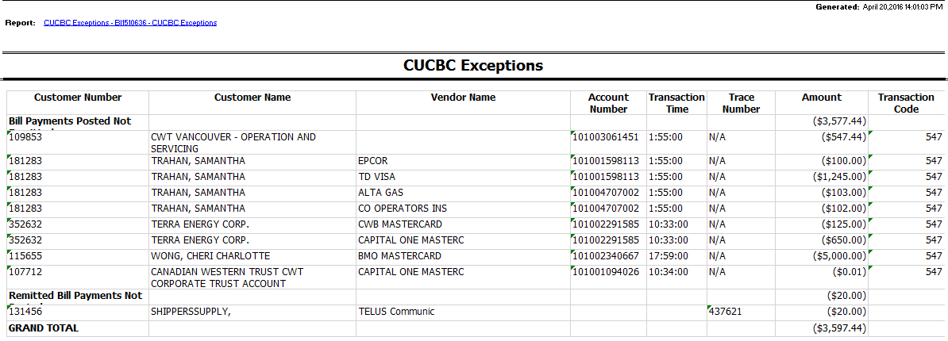

**1234**

These are all rejects from the BPRT report – label them as “Possible Duplicates”

This time indicates all these transactions were held back during rights-off and posted after midnight

CENTRAL1 08/29/14  **BPRT** 083169920 CENTRAL 1 CREDIT UNION PAGE: 213

BILL PAYMENTS - REJECTED TRANSACTIONS RUN DATE 08/30/14

CREDIT UNION 699 BRANCH 2 (CANADIAN WESTERN BAN) RUN TIME 00:47:09

==================================================================================================================================

MEMB.ACCT RE EXPLANATION VENDOR NAME VENDOR ACCT TXN TIME TXN AMT TRACE

**1234**

01615061 94 POSSIBLE DUPLICATE TXN. TXN IGNORE CWB MASTERCARD 5491981353636661 13:03:38 125.00 442848

10462828 94 POSSIBLE DUPLICATE TXN. TXN IGNORE CAPITAL ONE MASTERC 5491397555893200 09:55:35 650.00 415718

10567055 94 POSSIBLE DUPLICATE TXN. TXN IGNORE BMO MASTERCARD 5583460004212338 12:31:25 5,000.00 438746

12155578 94 POSSIBLE DUPLICATE TXN. TXN IGNORE CAPITAL ONE MASTERC 5524978490097675 11:05:20 0.01 426595

*******************************************************

* TOTAL NUMBER OF REJECTED ITEMS: 4 *

* TOTAL AMOUNT OF REJECTED ITEMS: 5,775.01 *

*******************************************************

### Example🡪 Completed Internal Account Reconciliation

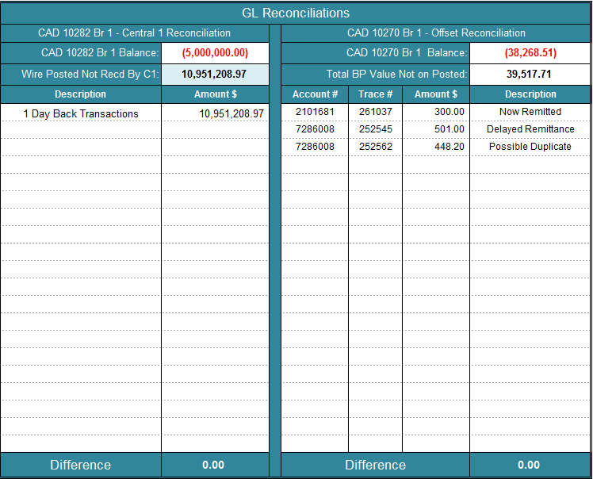

From Grand Totals

Automatic entry

Fr BPRT Rejects

Fr BPs Posted

Fr BPs Not Posted

Fr previous day

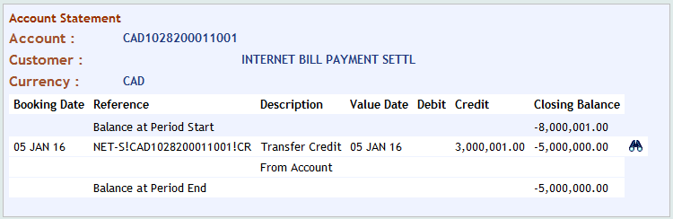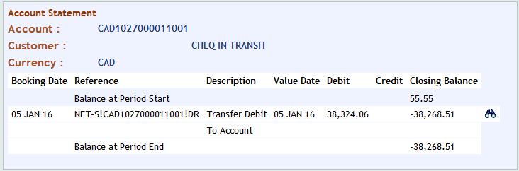

***Determining Reconciling Items from Reporting:***



Possible Duplicate

Delayed Vendor

CENTRAL1 08/07/14 **BPRT** 083169920 CENTRAL 1 CREDIT UNION PAGE: 155

BILL PAYMENTS - REJECTED TRANSACTIONS RUN DATE 08/08/14

CREDIT UNION 699 BRANCH 2 (CANADIAN WESTERN BAN) RUN TIME 00:39:37

==================================================================================================================================

MEMB.ACCT RE EXPLANATION VENDOR NAME VENDOR ACCT TXN TIME TXN AMT TRACE

09896671 6 REVERSED BY USER TELUS MOBILITY INC. 19127602 08:18:26 27,749.00 308239

11832623 94 POSSIBLE DUPLICATE TXN. TXN IGNORE AMERICAN EXPRESS 373386655061002 01:35:48 448.20 868516

*******************************************************

* TOTAL NUMBER OF REJECTED ITEMS: 2 *

* TOTAL AMOUNT OF REJECTED ITEMS: 28,197.20 *

*******************************************************



**Total BP’s Not on Report 1**

**One day back Transactions**

# Corrections & Banking/LOC Charges Overview

After the reconciliations have been completed, there are a number of correcting entries that need to be completed in order to make the CWB clients whole.

The entries that will require either corrections or postings are:

1. All posted rejects must be credited back to the client’s account effective the transaction date
2. All remitted payments that were not posted from a previous day must be posted (non-rights-off) with an effective date equal to the original transaction date
3. Settled trace requests
4. Banking and LOC Charges

## Posting Correction Entries

### Reports Required

1. **BPRT Report –** Bill Payments Rejected Transactions report
   * Each Rejected item that posted must be corrected
2. **Bill Payments Posted Not Remitted by Central 1**
   * Use this report in tandem with the BPRT report to determine all required details in order to correct the right items
3. **Remitted Bill Payments Not Posted** 
   * Each transaction with a time outside of the rights-off range & determined not to be a Delayed Remittance must be corrected
4. **Trace Requests** 
   * Documentation from traces that have settled provide the details behind the settlement

### Spreadsheet Used:

Central 1 Reconciliation- Direct Pay - **Tab # 3 🡪 Correction Form**

### Preparing the Correction Entries:

Using the top portion of the Correction Form input each individual BP that requires correction completing each field with the correct information:

1. ***Reason for Posting*** 🡪 Choose the appropriate reason from the drop down list
2. ***UCM*** 🡪 Input the client account number
3. ***Prefix*** 🡪 Input the account prefix from the original transaction
4. ***Original BP Date*** 🡪 this is the date the transaction took place
5. ***Effective Date*** 🡪 this is the effective date of the correcting entry
6. ***Trace #*** 🡪 each BP has its own unique Ref # 🡪 input the original BP Ref # (6 digits)
7. ***Vendor Name*** 🡪 Input the Vendor Name as it appears on the BPRT report
8. ***Amount*** 🡪 Input the amount of the BP
9. ***S/C*** 🡪 Choose the correct service charge indicator from the drop down list 🡪 ***Yes or No or NA***
10. ***SC Amount*** 🡪 the service charge amount will auto-populate 🡪 no input is required
11. Once all the data for all the corrections have been entered into the top section, post the entries as indicated in the bottom section
12. Print ***two*** copies 🡪 front to back
    1. ***Copy # 1*** to be included with reconciliation
    2. ***Copy # 2*** to be included in your blotter once it has been verified

Notes:

* If these entries are not posted your reconciliation will be out the following day
* The form allows for 10 corrections at one time.
* The form will create & auto-populate a posting transaction directly below the data input section.

## Posting Banking & LOC Charges:

### Reports Used:

1. **Central 1 Statement** 
   * If there is a banking charge or an LOC Charge listed on the banking system there will be a transaction listed on the statement that is neither a bill payment nor a trace settlement
   * ***Line of Credit charges*** – LOC Charges are debited from the account on an annual basis in early February 🡪 this charge will usually appear as a ***DM Debit Memo*** on the C1 statement
   * ***Banking Charges*** such as interest earned may appear as ***CM Credit Memo*** on the C1 statement
   * ***Banking charges*** such as overdraft fees may appear as ***DM Debit Memo*** on the C1 statement

See example of LOC Charges below

### Spreadsheet Used:

Central 1 Reconciliation- Direct Pay - **Tab # 4 🡪 Banking & LOC Charges**

**Preparing the Entries for Banking & LOC Charges:**

1. Using the information from the transaction entry on the Central 1 BP account statement, enter the value of the banking charges, interest or the LOC Charges in the appropriate field of the Banking & LOC Charges spreadsheet
2. Post the resulting entry or entries
3. Print 2 copies of the spreadsheet
   1. Keep one copy will remain with the reconciliation
   2. Send one copy will be sent to Finance including a copy of the Central 1 BP statement

## Examples of Source Data and the Correction & Banking & LOC Charges Forms

**BPRT Report – Example of rejected items**

CENTRAL1 06/10/14 BPRT 083169920 CENTRAL 1 CREDIT UNION PAGE: 152

BILL PAYMENTS - REJECTED TRANSACTIONS RUN DATE 06/11/14

CREDIT UNION 699 BRANCH 2 (CANADIAN WESTERN BAN) RUN TIME 01:08:46

==================================================================================================================================

MEMB.ACCT RE EXPLANATION VENDOR NAME VENDOR ACCT TXN TIME TXN AMT TRACE

05273214 71 INVALID VENDOR ACCOUNT APEGA M23610 21:34:25 304.50 471064

09167941 94 POSSIBLE DUPLICATE TXN. TXN IGNORE TELUS SERVICES INC 16000001246788 07:48:57 1,304.10 422322

09178567 94 POSSIBLE DUPLICATE TXN. TXN IGNORE SCOTIA BANK - LINE 4538166999511 12:14:49 500.00 440981

12102141 94 POSSIBLE DUPLICATE TXN. TXN IGNORE CRA PAYROLL CURRENT 100031319RP0001 02:32:24 26,927.45 759501

*******************************************************

* TOTAL NUMBER OF REJECTED ITEMS: 4 *

* TOTAL AMOUNT OF REJECTED ITEMS: 29,036.05 *

*******************************************************

**Bill Payments Posted Not Remitted by Central 1 – Posted items compared to rejected items**

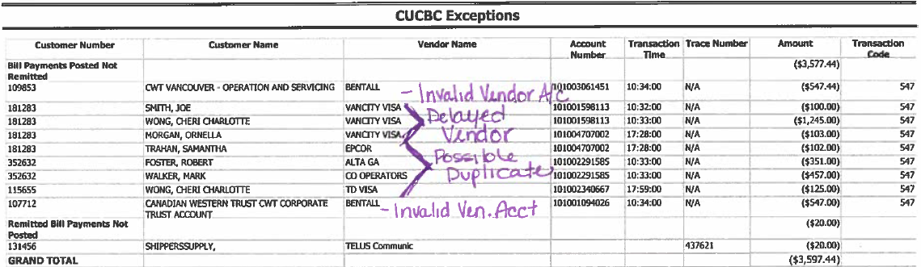

**Remitted Bill Payments Report - Example of an item that the banking system did not post**



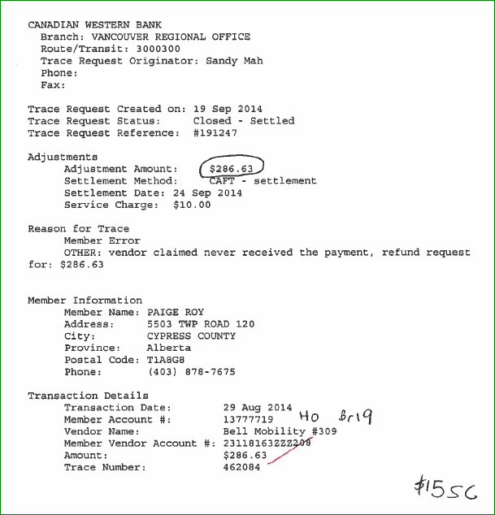**Settled Trace – Example of Data from a trace Report**

**Example Resulting Spreadsheet – Central 1 Reconciliation – Direct Pay – Tab # 3 Correction Form**

This is how the above data would appear once input into the Correction Form🡪 Top Section

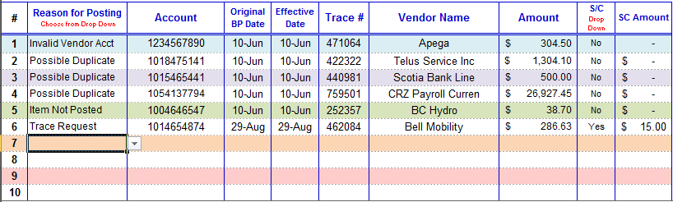

The spreadsheet will then generate the posting entries required to correct the clients🡪 this is how the posting entries would appear based on the data input into the top section🡪 Bottom Section

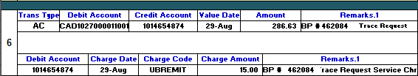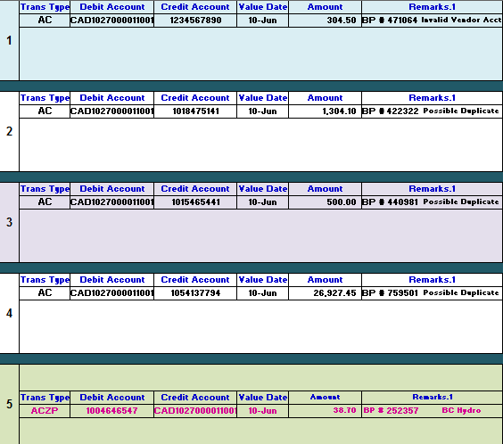

**Banking & LOC Charges** – **Example of Central 1 Account Statement with Charges**

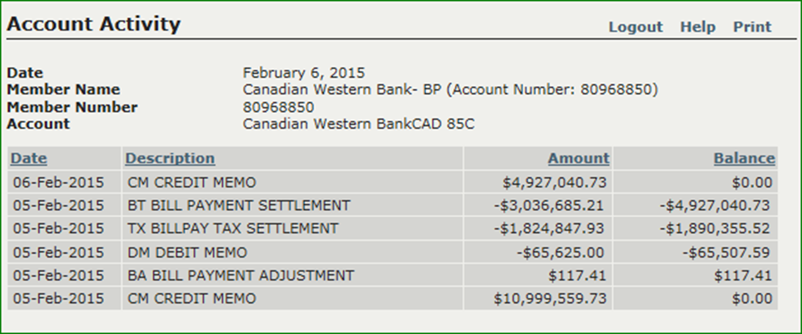

Example of Annual LOC Charges

**Example Resulting Spreadsheet – Central 1 Reconciliation – Direct Pay – Tab # 4 Banking & LOC Charges**

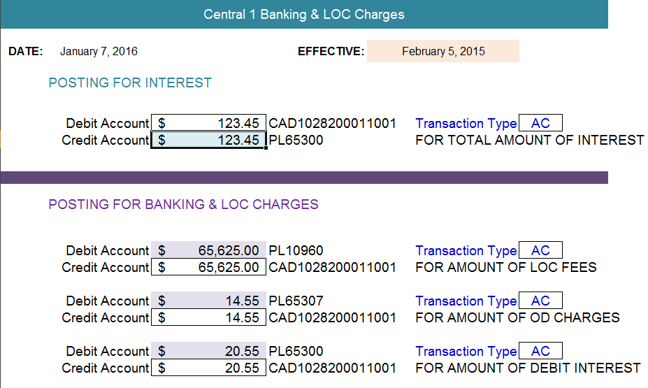

**For any 🡪**

* **LOC Fees**
* **OD charges**
* **Debit Interest**

**Debited to the account list the amount in the highlighted field and post the resulting entry as indicated**

**For any interest credited to the account list the amount in the highlighted field and post the resulting entry as indicated**

# Branch Notifications

* CAP ***must notify*** the Branches of any client transactions that have failed ***no later than 2 PM MT***
* ***Ideally***, the branches should be notified as part of the reconciliation process & therefore the branches will be notified ***before noon MT*** & give them ample time to notify their clients.
* The branches will inform their clients of the item(s) & the nature of the failure
* Once the client has been notified of the failed BP, the client will determine & take appropriate actions to resubmit the bill payment.
* The failed Bill Payments that CAP must report to the branches are:
  + The rejected BP’s from the BPRT report
  + The rejected Future-dated BP from the BPRF report
  + Returned BP’s initiated & returned by the vendor

***Staff Accounts*** *🡪 if the client account # has been identified as a* ***STAFF*** *account, the CAP admin must notify the staff member directly. Under no circumstances must staff information be sent to the Retail Contacts.*

*For CDI & National Leasing staff, contact HR*



## How to Notify the Branches of Failed Bill Payments

### BPRT Report – Rejected Bill Payments

1. ***Copy and paste*** all items listed on the BPRT report into a blank Word Doc.
2. ***Run*** the HOBS macro 🡪 **ALT F8** to change the doc from portrait to landscape
3. ***Save*** the doc into the G Drive 🡪 **G:\Direct Pay\Direct Pay Reject Notices**
4. ***Name*** the doc as the date to be reconciled 🡪 if you are reconciling September 10th name the doc ***Sept10-BPRT***
5. For each rejected BP, add the client’s branch # at the far right of the item
6. Save the document
7. Email the branch Retail contacts identified in step 6 using the contacts listed in the Retail & NSF Contacts
   1. The Retail & NSF Contacts can be located at 🡪 ***G:\Clearing Process***
   2. ***Always*** include at least ***2 contacts per branch*** to ensure that someone at the branch has received the email
   3. ***Never*** send the email to only ***one recipient***
8. ***BCC*** yourself 🡪 if your position requires it, include your supervisor as a ***CC***
9. Use the following email verbiage in the body of your email 🡪 no other verbiage is acceptable

*REJECTS BPRT*

*Hello,*

*Please find attached report showing rejected bill payments. Please locate your clients’ transactions via the branch numbers highlighted, contact them to advise them of the reason listed for the reject and that if required the payment will need to be resubmitted by the client.*

*If you have any questions, please feel free to contact me.*

*Thank you,*

1. Attach the BPRT report saved with the details of the rejected bill payments & branch #’s
2. Print a copy of the email sent to the branches and attach it to the reconciliation as proof of contact

### BPRF Report – Future-Dated Rejected Bill Payments

1. ***Copy and paste*** all items listed on the BPRF report into a blank Word Doc.
2. ***Run*** the HOBS macro 🡪 **ALT F8** to change the doc from portrait to landscape
3. ***Save*** the doc into the G Drive 🡪 **G:\Direct Pay\Direct Pay Reject Notices**
4. ***Name*** the doc as the date to be reconciled 🡪 if you are reconciling September 10th name the doc ***Sept10-BPRF***
5. For each rejected BP, add the client’s branch # at the far right of the item
6. Save the document
7. Email the branch Retail contacts identified in step 6 using the contacts listed in the Retail & NSF Contacts
8. The Retail & NSF Contacts can be located at 🡪 ***G:\Clearing Process***
   1. ***Always*** include at least ***2 contacts per branch*** to ensure that someone at the branch has received the email
   2. ***Never*** send the email to only ***one recipient***
   3. ***BCC*** yourself 🡪 if your position requires it, include your supervisor as a ***CC***
9. Use the following email verbiage in the body of your email 🡪 no other verbiage is acceptable

*FUTURE DATES BPRF*

*Hello,*

*Please find attached report showing rejected future dated bill payments. Please locate your client’s transactions via the branch numbers highlighted, contact them to advise them of the reason listed for the reject and that if required the payment will need to be resubmitted by the client.*

*If you have any questions, please feel free to contact me.*

*Thank you,*

1. Attach the BPRF report saved with the details of the rejected bill payments & branch #’s
2. Print a copy of the email sent to the branches and attach it to the reconciliation as proof of contact

### Administrative Options

* The CAP Admin may choose to copy and paste both the details of the BPRT & the BPRF reports into one document and send one email to all contacts being sure to include the verbiage for both types of rejects.
* The CAP admin may add the BPFC report to the same document and print the document for the reconciliation process 🡪 this copy will include the branch numbers. This printed copy would then be used in the reconciliation process and included as backup.
* The CAP admin may choose to ask for a Read Receipt from the recipients when sending the email
* In Outlook 🡪Options tab 🡪under tracking 🡪 check off Request Read Receipt

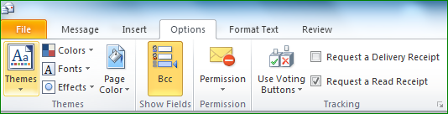

* The CAP admin may choose to save the document on to their desktop instead of the Direct Pay folder

### Example of BPRT & BPRF & BPFC Reports Used to Notify Branches

**CENTRAL1 09/10/14 BPRT** 083169920 CENTRAL 1 CREDIT UNION PAGE:162

BILL PAYMENTS - REJECTED TRANSACTIONS RUN DATE 09/11/14

CREDIT UNION 699 BRANCH 2 (CANADIAN WESTERN BAN) RUN TIME 01:03:01

==================================================================================================================================

MEMB.ACCT RE EXPLANATION VENDOR NAME VENDOR ACCT TXN TIME TXN AMT TRACE

**08206518 94 POSSIBLE DUPLICATE TXN. TXN IGNORE VANCITY VISA 4789010013134273 17:21:04 50.00 487091 Br 37**

**12331856 94 POSSIBLE DUPLICATE TXN. TXN IGNORE TELUS Communication 2138756969 01:52:53 53.05 893185 Br 12**

12582227 6 REVERSED BY USER PRESIDENT CHOICE MA 5181271069811823 13:49:06 487.52 531675

08051526 6 REVERSED BY USER TORONTO DOMINION -V 4520737001161264 08:55:21 3,000.00 509795

11503190 6 REVERSED BY USER CANADIAN TIRE MASTE 5446122549751447 01:52:49 1,300.00 892990

08141996 6 REVERSED BY USER CWB MASTERCARD 5452401187242070 14:01:03 10,814.00 532481

*******************************************************

* TOTAL NUMBER OF REJECTED ITEMS: 6 *

* TOTAL AMOUNT OF REJECTED ITEMS: 15,704.57 *

*******************************************************

**CENTRAL1 09/10/14 BPRF** 083169920 CENTRAL 1 CREDIT UNION PAGE:12

BILL PAYMENTS - FUTURE DATED REJECTED TRANSACTIONS RUN DATE 0

CREDIT UNION 699 BRANCH 2 (CANADIAN WESTERN BAN) RUN TIME 01:03:01

==============================================================================================================================

AC/T MEMBER ACCT TRACE REASON EXPLANATION VENDOR NAME VENDOR ACCT TXN AMOUNT ORIGINAL TXN DATE

**H 000 04085056 792388 4 REJECTED BY HOST CRA (REVENUE)-TAX IN 608396941 8731.00 08/20/2014 Br 2**

*****************************************

* TOTAL ITEMS: 1 *

* EFFECTIVE DATE: 09/10/2014 *

*****************************************

**CENTRAL1 09/10/14 BPFC** 083169920 CENTRAL 1 CREDIT UNION PAGE: 61

BILL PAYMENTS - CANCELLED FUTURE DATED TRANSACTIONS RUN DATE 09/11/14

CREDIT UNION 699 BRANCH 2 (CANADIAN WESTERN BAN) RUN TIME 01:03:04

==============================================================================================================================

AC/T MEMBER ACCT TRACE REASON EXPLANATION VENDOR NAME VENDOR ACCT TXN AMOUNT ORIGINAL TXN DATE

P 000 01822386 722155 5 CANCELLED TELUS MOBILITY INC. 16253167 200.00 04/19/2014

C 000 04570180 848279 5 CANCELLED WORKERS COMP.BOARD - 2788308 1,293.29 01/23/2014

H 000 05653522 774184 5 CANCELLED CRA (REVENUE)-TAX IN 708871215 1,545.00 08/17/2014

C 000 06600753 866551 5 CANCELLED SCOTIA VISA 4538017103461064 1,208.53 09/03/2014

H 000 08019556 811515 5 CANCELLED CRA (REVENUE)-TAX IN 618847172 2,389.76 06/11/2014

H 000 08690125 783322 5 CANCELLED LEONS - VISA DESJARD 4530930778929009 120.00 08/19/2014

P 000 09896499 895057 5 CANCELLED WAWANESA INSURANCE 4627972 227.59 05/21/2014

P 000 09896499 895045 5 CANCELLED WAWANESA INSURANCE 4627972 296.80 05/21/2014

H 000 10419877 794139 5 CANCELLED TORONTO DOMINION -VI 4520880013712052 354.00 08/21/2014

H 000 11410123 805694 5 CANCELLED MEDICINE HAT - UTILI 5241231049597 328.06 08/23/2014

C 000 11570975 870881 5 CANCELLED FORTISBC-NATURAL GAS 3552320 91.00 09/04/2014

C 000 12483442 860615 5 CANCELLED ENMAX 500134321 858.52 09/02/2014

D 000 13479621 877912 5 CANCELLED PRESIDENT CHOICE MAS 5181271047826224 1,185.66 09/05/2014

*****************************************

* TOTAL ITEMS: 13 *

*****************************************

***In this example 🡪 Branches 2, 37, & 12 would be notified for rejected bill payments or directly with the clients if they are staff***

## Returned Bill Payments – Initiated & Returned by the Vendor

* When funds have been received in the Central 1 account & the source of the credit is due to a Vendor Initiated return of funds, the CAP Admin must notify the branch(es) so that the branch(es) can notify the client
* In order to determine if funds received from Central 1 are due to a returned BP payment, the CAP admin will access the On Line Tracing website for Central 1 Bill Payments to determine the bill payment & client details from reporting provided on this site
* Once the information is retrieved, the CAP Admin will determine which branch to contact
* Procedures on how to retrieve this information can be located in the chapter for ***Traces*** and Related Procedures

### Process

1. Email the branch Retail contacts for the branch identified in the information from Central 1 🡪 use the contacts listed in the Retail & NSF Contacts spreadsheet
   1. The Retail & NSF Contacts can be located at 🡪 ***G:\Clearing Process***
   2. ***Always*** include at least ***2 contacts per branch*** to ensure that someone at the branch has received the email
   3. ***Never*** send the email to only ***one recipient***
2. ***BCC*** yourself 🡪 if your position requires it, include your supervisor as a ***CC***
3. Use the following email verbiage in the body of your email filling in the required information 🡪 no other verbiage is acceptable

*CENTRAL 1 RETURNS*

*Hello,*

*Please be advised that the following bill payment was rejected by the vendor. Please contact your client to advise them of the reason listed for the reject and that if required the payment will need to be resubmitted by the client.*

*Transaction Date: MMDDYY*

*Account#: ##########*

*Vendor Name: XXXXXXXXXX*

*Amount: $$$$$.$$*

*Reference #: ######*

*Reason for reject: XXXXXXXXXX*

*If you have any questions, please feel free to contact me.*

*Thank you,*

1. Optionally, the CAP admin may copy and paste into the body of the email, the detailed information retrieved from the Central 1 report from the On Line Tracing website instead. The CAP admin must be sure to exclude any information that should not be sent to the client

***\*\*In all cases, whether the branch is contacted for a rejected bill payment or a vendor initiated return, the CAP Admin is not required to do follow up & track any responses from the branches\*\****

### Example of a Vendor Initiated Return Report

CANADIAN WESTERN BANK

Branch: CANADIAN WESTERN BANK

Route/Transit: 83169920

Trace Request Originator: Kari Hedrick

**Do not include any of the information from this section into your email to the branches**

Phone:

Fax:

Trace Request Created on: 06 Oct 2014

Trace Request Status: Closed - Settled

Trace Request Reference: #192393

Adjustments

Adjustment Amount: $1,011.00

Settlement Method: CAFT - settlement

Settlement Date: 06 Oct 2014

Service Charge: $10.00

***Reason for Trace***

Vendor Initiated

INVALID ACCOUNT

ATTENTION VENDOR: As per your request, please sign Authorization and fax back to 604.730.4403.CREDIT UNION: This payment was made to Invalid Account. The adjustments have been posted to your account.

***Member Information***

**It is okay to include any of the information from this section into your email to the branches (or staff)**

Member Name: MERLEEDNA FERGUSON

Address:

City:

Province:

Postal Code:

Phone:

***Transaction Details***

Transaction Date: 03 Oct 2014

Member Account #: 1796572 BR 9

Vendor Name: Peace Hills General Insurance Company #9927

Member Vendor Account #: D53365

Amount: $1,011.00

Trace Number: 139286

# CWB – Central 1 Transaction Response Codes

* A transaction response code is assigned to each Bill Payment transaction.
* The transaction code identifies the status of a BP transaction.
* All rejected or failed transactions will also have a transaction response code.
* If a client or branch enquires about their transaction, the codes will aide in determining the status of the transaction

Here is a detailed list of all the available transaction response codes and their description. Most descriptions are self-explanatory. A few descriptions require further explanation and are provided to the right 🡪

|  |  |  |
| --- | --- | --- |
| Code # | Description | Explanation |
| 0 | Normal, no error |  |
| 3 | Invalid Merchant |  |
| 4 | Rejected by Host ***** | CWB’s banking system did not approve the BP |
| 5 | Cancelled |  |
| 6 | Reversed by User |  |
| 8 | Invalid Information |  |
| 12 | Invalid Message |  |
| 13 | Invalid Dollar Amount |  |
| 14 | Invalid Member |  |
| 17 | Client Cancelled |  |
| 25 | Record Not Found |  |
| 26 | Duplicate Record in File |  |
| 30 | Format Error |  |
| 31 | Invalid Acquirer Institution |  |
| 51 | Insufficient Funds |  |
| 56 | Card Holder not on File |  |
| 64 | Invalid Original Amount |  |
| 66 | Missing Form **** | For certain CRA payments, clients must complete an additional online form before submitting the payment. If the form has not been completed, the payment is rejected with code 66. |
| 68 | Missing Payment |  |
| 71 | Invalid Vendor Account |  |
| 74 | Operator Cancelled |  |
| 84 | Issuer Down |  |
| 85 | Invalid Originator or Processor |  |
| 90 | Cut-Off Process |  |
| 91 | Message Time-Out |  |
| 92 | Issuer not Found |  |
| 94 | Possible Duplicate Txn – Txn Ignored |  |
| 95 | Over Limit Payment |  |
| 96 | Internal Switch Error *** | There was a system error at Central 1 that caused the BP to fail |
| 97 | Key Exchange in Process |  |
| 98 | Switch Considers Originator Down ** | Communications between Central 1 & CWB were severed 🡪CWB could not respond to approve or disapprove a BP |
| 99 | Invalid Authorization |  |

If the code you are investigating is not listed in the table above, this supplementary table can be useful as an alternative source.

|  |  |  |
| --- | --- | --- |
| Response Code Received | Assumed Response Code at ARU | Description |
| **00** | **00** | Successful Transaction |
| **03** | **03** | Invalid Utility Company |
| **12, 13, 30, 57, 86** | **06** | Invalid Message. Format error in message or field. |
| **14** | **14** | Invalid Member |
| **15** | **15** | Wrong Access Code.  First time member has entered the system. Get a new access code. |
| **25** | **25** | Future Dated Transaction not found.  Used in Future Dated Reply messages from the Bill Payment Switch only |
| **26** | **26** | Account Number Already Exists |
| **28, 29, 77, 80, 89, 90, 91, 94, 96, 97, 98**  **and any others that don't fit in the other categories** | **99** | System Error. "System Unavailable at this time".  Log Transaction Information and Error Code. |
| **33, 41, 43, 56, 62, 65, 67, 78, 81, 82, 83, 84, 85, 92,** | **98** | Information Setup Error.  "System Unavailable at this time. Please Contact your Credit Union Representative".  Log the Transaction and the Error Code for further analysis. |
| **31** | **31** | Invalid Credit Union. (Information Setup Error or Access before "Production Date") |
| **40** | **40** | Future Dated Transaction found for Vendor in a "Vendor Delete Request" message |
| **51** | **51** | Insufficient Funds |
| **61** | **61** | Exceeds Withdrawal Limit.  (Same effect as 51 but this is in off-line mode.) |
| **75** | **75** | Access Code Tries Exceeded |
| **79** | **79** | Invalid Account Number or Account number not found on Database. |

## Examples of Transaction Response Codes on the Central 1 Reports

**CENTRAL1 09/10/14 BPRT** 083169920 CENTRAL 1 CREDIT UNION PAGE:162

BILL PAYMENTS - REJECTED TRANSACTIONS RUN DATE 09/11/14

CREDIT UNION 699 BRANCH 2 (CANADIAN WESTERN BAN) RUN TIME 01:03:01

==================================================================================================================================

MEMB.ACCT RE EXPLANATION VENDOR NAME VENDOR ACCT TXN TIME TXN AMT TRACE

**08206518 94 POSSIBLE DUPLICATE TXN. TXN IGNORE VANCITY VISA 4789010013134273 17:21:04 50.00 487091 Br 37**

**12331856 94 POSSIBLE DUPLICATE TXN. TXN IGNORE TELUS Communication 2138756969 01:52:53 53.05 893185 Br 12**

12582227 6 REVERSED BY USER PRESIDENT CHOICE MA 5181271069811823 13:49:06 487.52 531675

08051526 6 REVERSED BY USER TORONTO DOMINION -V 4520737001161264 08:55:21 3,000.00 509795

11503190 6 REVERSED BY USER CANADIAN TIRE MASTE 5446122549751447 01:52:49 1,300.00 892990

08141996 6 REVERSED BY USER CWB MASTERCARD 5452401187242070 14:01:03 10,814.00 532481

*******************************************************

* TOTAL NUMBER OF REJECTED ITEMS: 6 *

* TOTAL AMOUNT OF REJECTED ITEMS: 15,704.57 *

*******************************************************

**CENTRAL1 09/10/14 BPRF** 083169920 CENTRAL 1 CREDIT UNION PAGE:12

BILL PAYMENTS - FUTURE DATED REJECTED TRANSACTIONS RUN DATE 0

CREDIT UNION 699 BRANCH 2 (CANADIAN WESTERN BAN) RUN TIME 01:03:01

==============================================================================================================================

AC/T MEMBER ACCT TRACE REASON EXPLANATION VENDOR NAME VENDOR ACCT TXN AMOUNT ORIGINAL TXN DATE

**H 000 04085056 792388 4 REJECTED BY HOST CRA (REVENUE)-TAX IN 608396941 8731.00 08/20/2014 Br 2**

*****************************************

* TOTAL ITEMS: 1 *

* EFFECTIVE DATE: 09/10/2014 *

*****************************************

**CENTRAL1 09/10/14 BPFC** 083169920 CENTRAL 1 CREDIT UNION PAGE: 61

BILL PAYMENTS - CANCELLED FUTURE DATED TRANSACTIONS RUN DATE 09/11/14

CREDIT UNION 699 BRANCH 2 (CANADIAN WESTERN BAN) RUN TIME 01:03:04

==============================================================================================================================

AC/T MEMBER ACCT TRACE REASON EXPLANATION VENDOR NAME VENDOR ACCT TXN AMOUNT ORIGINAL TXN DATE

P 000 01822386 722155 5 CANCELLED TELUS MOBILITY INC. 16253167 200.00 04/19/2014

C 000 04570180 848279 5 CANCELLED WORKERS COMP.BOARD - 2788308 1,293.29 01/23/2014

H 000 05653522 774184 5 CANCELLED CRA (REVENUE)-TAX IN 708871215 1,545.00 08/17/2014

C 000 06600753 866551 5 CANCELLED SCOTIA VISA 4538017103461064 1,208.53 09/03/2014

H 000 08019556 811515 5 CANCELLED CRA (REVENUE)-TAX IN 618847172 2,389.76 06/11/2014

H 000 08690125 783322 5 CANCELLED LEONS - VISA DESJARD 4530930778929009 120.00 08/19/2014

P 000 09896499 895057 5 CANCELLED WAWANESA INSURANCE 4627972 227.59 05/21/2014

P 000 09896499 895045 5 CANCELLED WAWANESA INSURANCE 4627972 296.80 05/21/2014

H 000 10419877 794139 5 CANCELLED TORONTO DOMINION -VI 4520880013712052 354.00 08/21/2014

H 000 11410123 805694 5 CANCELLED MEDICINE HAT - UTILI 5241231049597 328.06 08/23/2014

C 000 11570975 870881 5 CANCELLED FORTISBC-NATURAL GAS 3552320 91.00 09/04/2014

C 000 12483442 860615 5 CANCELLED ENMAX 500134321 858.52 09/02/2014

D 000 13479621 877912 5 CANCELLED PRESIDENT CHOICE MAS 5181271047826224 1,185.66 09/05/2014

*****************************************

* TOTAL ITEMS: 13 *

*****************************************

# Traces, Recalls & Same Day Reversals

All BP transaction traces are initiated, executed and managed online via a Central 1 secured website called OLT – Online Tracing. Each admin will be provided with their own user ID & password for access to Online Tracing. Hard copy documentation of all traces is also maintained.

**OLT – Online Tracing URL** - <https://www.secure.central1.com/Pages/Applications.aspx>

A trace or recall can be completed for several reasons:

1. The vendor may be claiming that the client’s payment was not received and the client wishes to trace the item to the vendor
2. The client wishes to recall or request a refund from a vendor 🡪 this BP was completed in the past
3. A Same Day Reversal is a request from the client where a BP was initiated & completed current day, but the client does not wish for the payment to go through. A special request can be made to Central 1 to remove the BP from their repository of BP’s to be remitted so that the item is not processed.

## Service Charges for Client & Vendor Initiated Traces / Recalls & Same Day Reversals

* Staff Accounts 🡪 $10.00
* Non-staff Accounts 🡪 $15.00

*Waiving of any staff service charges are to be referred to the Senior Manager, CAP Deposits.*

## Types of Traces

There are 2 types of traces:

1. ***Client initiated traces*** 🡪 the client has requested a refund or a recall of the payment to the vendor
2. ***Vendor initiated traces*** 🡪 the vendor has rejected & returned the payment from a CWB client

### OLT – Online Tracing Website

Access the ***Central 1 OLT - On Line Tracing*** URL🡪 <https://www.secure.central1.com/Pages/Applications.aspx>

### OLT – On Line Tracing User Types

|  |  |  |
| --- | --- | --- |
| User Classification | Staff | Capabilities |
| Tracers | **CAP Admins** | * Can initiate a trace * Requires an approval by a Super Tracer * Can perform searches & create reports |
| Super Tracers | **CAP Managers** | * Can approve traces * Can initiate traces without approval * Can perform searches & create reports |

Begin by inputting your login details 🡪 user ID & password 🡪 then click

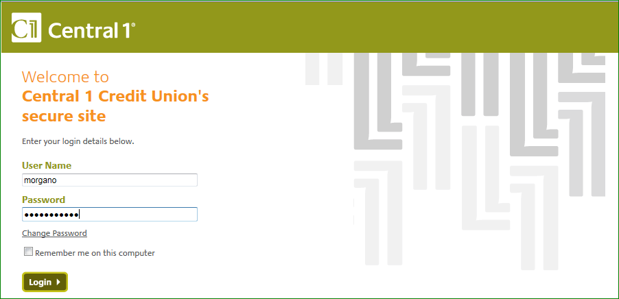

The following screen appears 🡪 you must now navigate to your profile options:

* Under ***My Work***🡪 Select🡪 ***Applications***

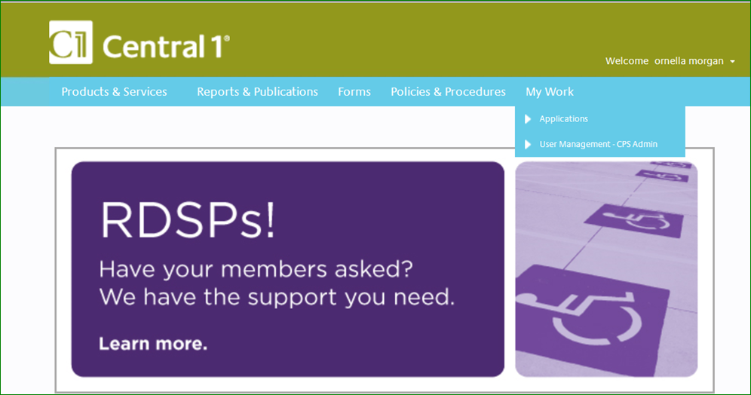

To access the OLT Online Tracing platform:

Click on the link for ***OLT – Online Tracing Application***

Check off the ***Add App to Favourites box***

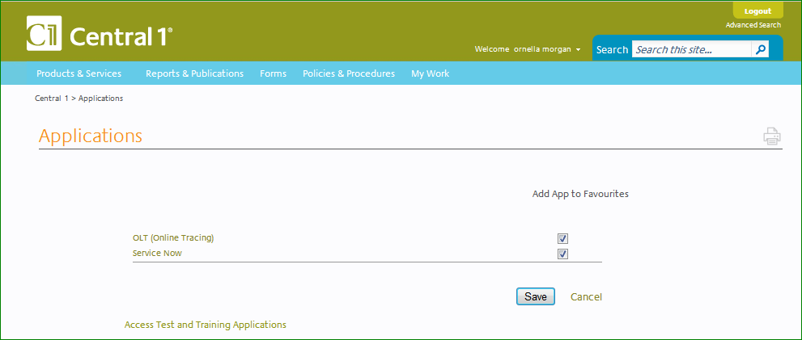

The following screen will appear 🡪 this is the ***Home Page***:

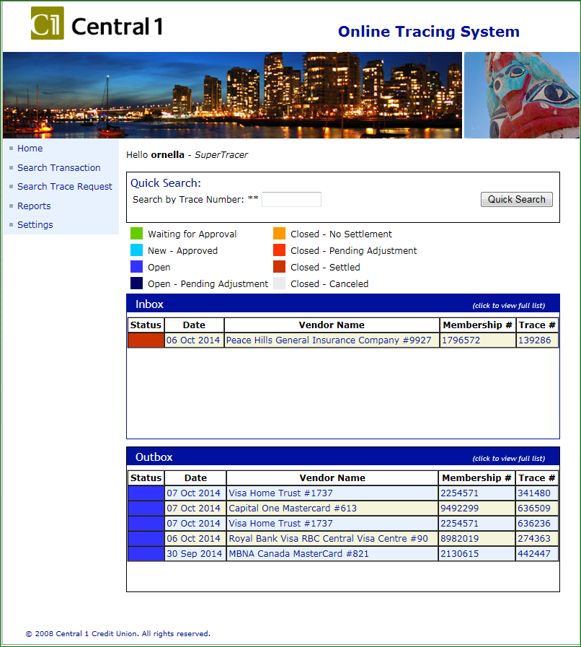

List of initiated but not completed traces

List of completed traces

Look for an item using the Quick Search

Legend of trace statuses

This is the menu of available functions within OLT

**For complete details on the use of the OLT - On Line Tracing website🡪consult the OLT Manual**



The On Line Tracing manual can also be accessed in the following folder ***🡪 G:\Direct Pay\Online Tracing Manual***

## Client Initiated Traces

If a client wishes to request a refund for a payment that was completed on a date in the past, they will contact their branch representative.

***Bill Payments made to the CRA can only be recalled on the same day as they are initiated. If the payment has been made on a previous day, the trace / recall cannot be completed. Only Same Day Reversals can be completed on CRA Payments. In these cases, the client must deal directly with the CRA***



The branch will contact CAP with an email requesting the recall of the payment & providing the following details:

1. Client Account #
2. Date of BP
3. Amount of BP
4. Reference # of BP
5. Vendor of BP

If the branch has not already confirmed that the client agrees to pay the service charges that apply to traces, respond to the branch email to inform them that the client will be subject to a service charge. Ask the branch to confirm that the client agrees to the service charges & only continue with the trace if the branch / client have authorized CAP to proceed.

Once you have obtained approval from the branch / client, print the email to use as your source document

Print a screen shot of the BP transaction posted to the client’s account

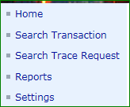**Initiate the trace by searching for the item:**

Start by choosing the Search Transaction menu options

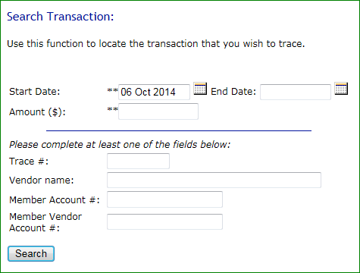The following screen will appear

The two fields with asterisks are mandatory fields.

Only one of the fields below the blue line is required, but any # of these fields can be completed to initiate a search.

To locate a specific BP, the Trace # field is information that is always readily available, easy to input & specific enough that it will generate better search results.

When searching for multiple BP’s for the same amount, a date range is more effective than a specific date & will generate more results.

The CAP admin can utilize any combination of fields to successfully search an item

Once the appropriate fields have been completed 🡪 click

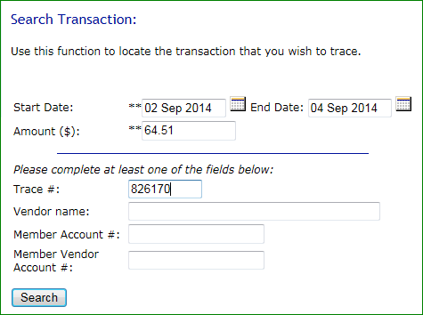

The OLT tracing system will locate the transaction & display the resulting details about the searched BP

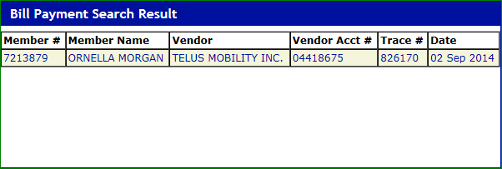

The entry will be highlighted in a soft yellow colour

* Verify the transaction information to ensure the correct BP has been retrieved
* Then click on any of the fields within the details of the BP transaction

If there are multiple search results, be sure to choose the correct BP transaction

Choosing the BP transaction from the search results will display the details about the BP transaction

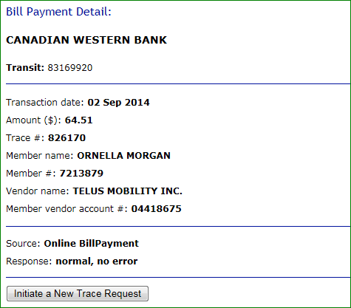

To initiate a trace request on the selected item 🡪 click

Choosing to Initiate a New Trace Request will generate another window where further information is required before the trace request is implemented

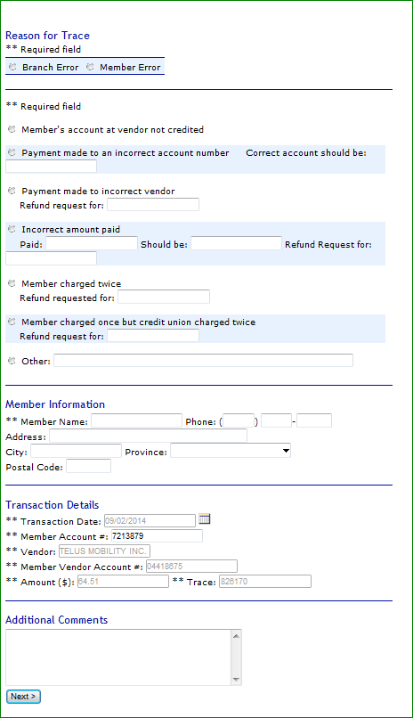Complete all required fields:

### Completing Trace Details Form

Select **Reason for Trace**

Select **the action required** by C 1

* If the client is claiming the vendor has not received the payment & only a payment status is required 🡪 select this option 🡪 no other details are required
* If the client has made a payment to the incorrect account # 🡪 select this option & provide the correct account # - this option is ***NOT Recommended***
* If the client has made the payment to the wrong vendor 🡪select this option & input the amount of the refund requested
* If the client has paid too much to a vendor🡪select this option & provide the original amount paid, the amount that should have been paid & the amount of the refund requested
* No other actions should be used for CWB transactions

**Member Information**

🡪Input the CWB’s client

* Name
* City & Province of residence

**Transaction Details** are already filled in 🡪this information is drawn from your original transaction search

**Additional Comments**

* If additional instructions or comments are required for Central 1, entered them in this section
* For example🡪 ”Urgent request” or “Possible Fraud!”

Once all the required information has been entered 🡪 click

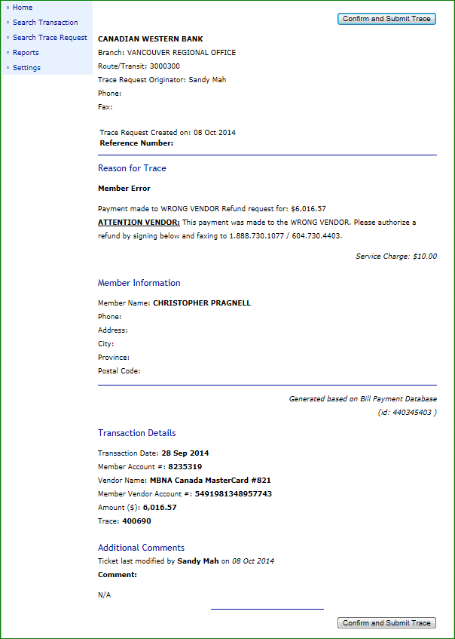Another screen will appear. The Tracer should verify the information requested prior to submitting the trace request for approval.

Review the information to ensure the correct BP has been selected and that the appropriate details have been entered.

Once you have verified the information click 🡪

The Confirm & Submit buttons are located at the top right as well as the bottom right of the screen

Once the trace has been confirmed & submitted the Tracer will get a final confirmation page. At this point, the Tracer has the option of 🡪

* Deleting / Rejecting Trace Request
* Modifying Trace Request
* Downloading the Request as Text

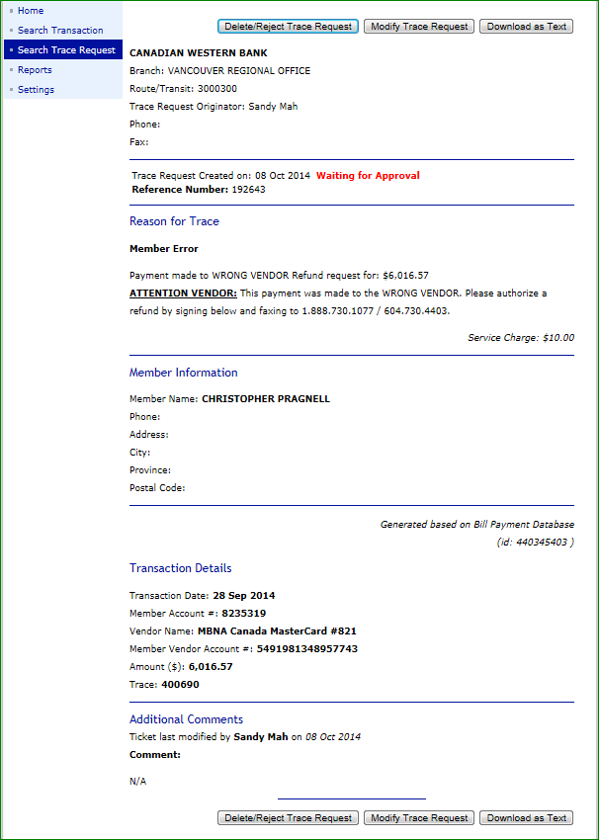If the trace request should not be processed 🡪 Select Delete 🡪 Confirm the Deletion

If the trace details require modifications or changes 🡪 Select Modify 🡪make the necessary changes then Confirm & Submit once again

If the trace request is good-to-go 🡪 Select Download as Text

Print the trace request by clicking 🡪

From the internet Explorer Option bar that will appear at the bottom of your screen 🡪 click **Open**



The trace request will be converted to a Word Doc 🡪 Print the report

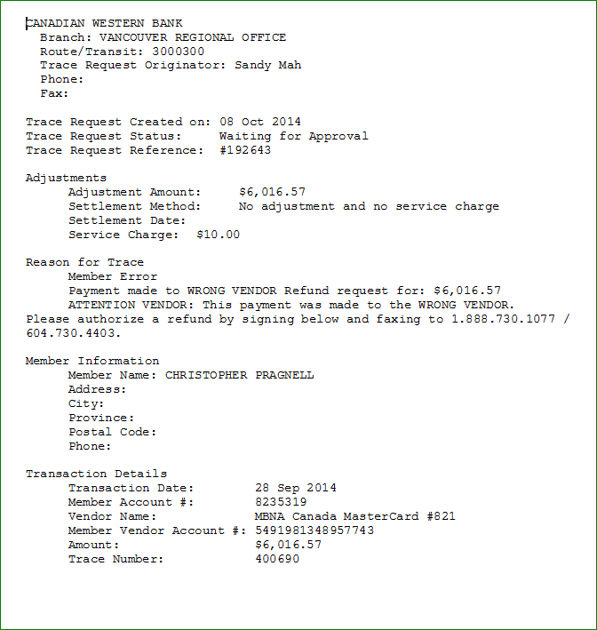

Gather the following documents & staple them together

1. Trace request report
2. Banking system transaction print out
3. Email request from branch

On the trace request report add the following information 🡪

* Client account type
* The client branch
* The amount of applicable service charges

The trace request documentation is now complete. Bring the documentation to a supervisor (Super Tracer) for approval. Once the Super Tracer has approved the trace request, they will sign the documentation complete with their signing authority number.

## Approving a Trace Request – Super Tracers Only

Once a trace request is ready for approval, the Super Tracer must log into the OLT – On Line Tracing URL

Access the ***Central 1 OLT - On Line Tracing*** URL🡪 <https://www.secure.central1.com/Pages/Applications.aspx>

Complete the log in process

The Super Tracer must be in possession of all the tracing documentation created by the Tracer

From the list of Traces in the Inbox, & based on the documentation provided select the trace that requires approval

The traces that require approval have a **Green status** as outlined by the legend

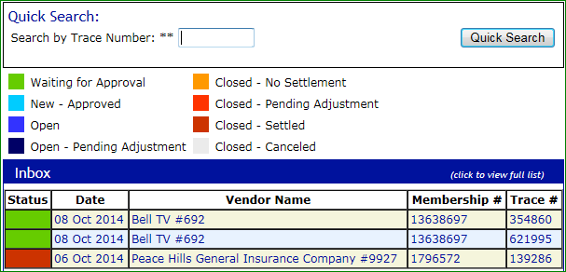

Verify the details of the trace request to the documentation provided 🡪 be sure to use the information from the branch, the banking system print out as well as the requested details on the trace report match to ensure the admin has selected the correct BP.

If the trace request details are correct, then select 🡪

If there is an error in any of the details, then you can select 🡪

If you choose this option, the admin will have to restart the trace process

Alternatively, the Super Tracer may inform the admin that a modifiable error has been made & then the admin can make the changes to the trace before it is presented for final approval

If there is an error in a field that can be modified then select 🡪

Once the trace request has been approved, the Super Tracer is to sign the documentation complete with their signing authority number.

### Approval Screen

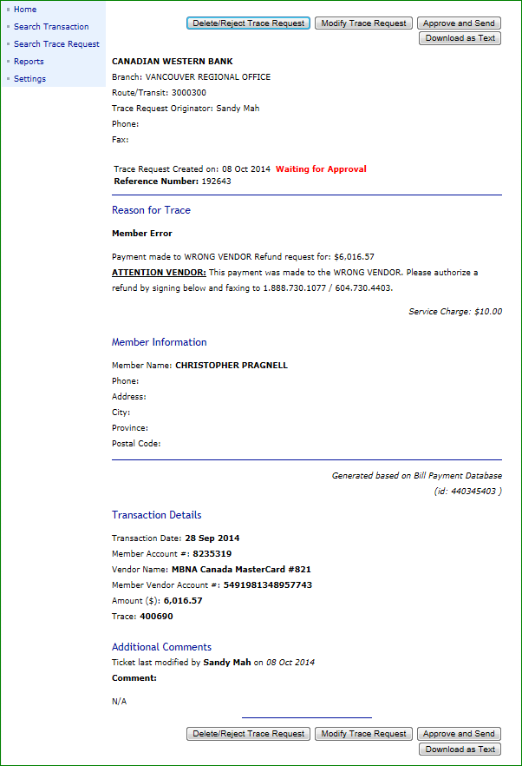

Once the Approve and Send option has been made the following confirmation window will appear:

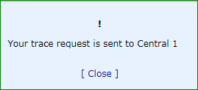

Once the trace request has been approved, the trace will move from the Inbox to the Outbox and the status will change from . Green – Waiting for Approval . to . Sky Blue – New – Approved . then when Central 1 has picked up the trace from the Outbox the status will change again to . Royal Blue – Open .

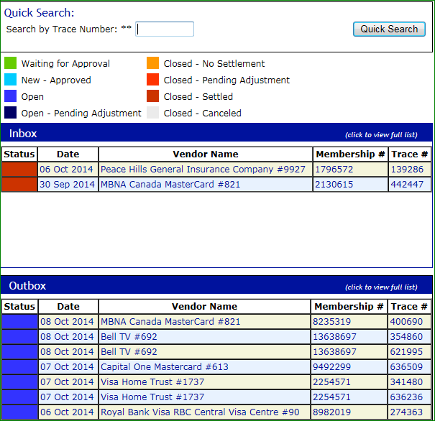

Return the trace request documentation to the Tracer

The CAP admin will maintain 2 folders for Bill Payment traces 🡪

1. Outstanding Traces
2. Completed Traces

* A trace will remain in the Outstanding Traces folder until settlement or resolution has been received.
* Central 1 will keep the trace active on their OLT for approximately 30 business days with intermittent requests to the vendor and responses to CWB every 10 business days.

Once settlement or resolution has been received 🡪

* Match the trace documentation
* Write the date the settlement was received on the front of the documentation
* Move the item into the Completed Traces folder

## Retrieving Trace Information for Settlement Values on the Central 1 Statement

Once a trace request has been settled, Central 1 will post a credit adjustment into CWB’s Bill Payment account.

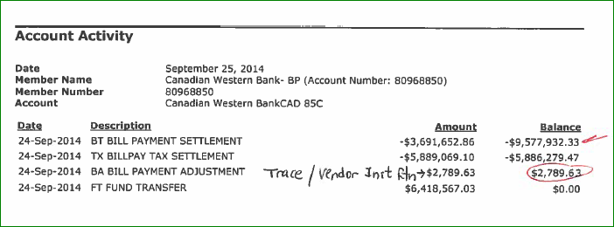

The credit adjustment is usually a lump sum of settlements for several trace requests.

To determine the individual trace request details behind the lump sum credited to the account a report will need to be retrieved from the Central 1 OLT - On Line Tracing website. The report is called the ***List of Closed – Settled Traces***

### How to Retrieve the List of Closed – Settled Traces Report

1. From the menu Functions 🡪 choose ***Reports***
2. 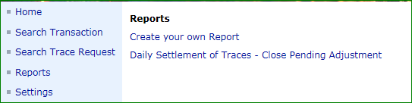Once in the Reports menu, select 🡪 ***Create your Own Report***
3. To create your report 🡪 input the date the credit adjustment was posted to the CWB account

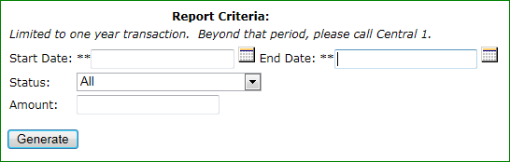

1. From the Status drop down 🡪 select ***Closed - Settled***

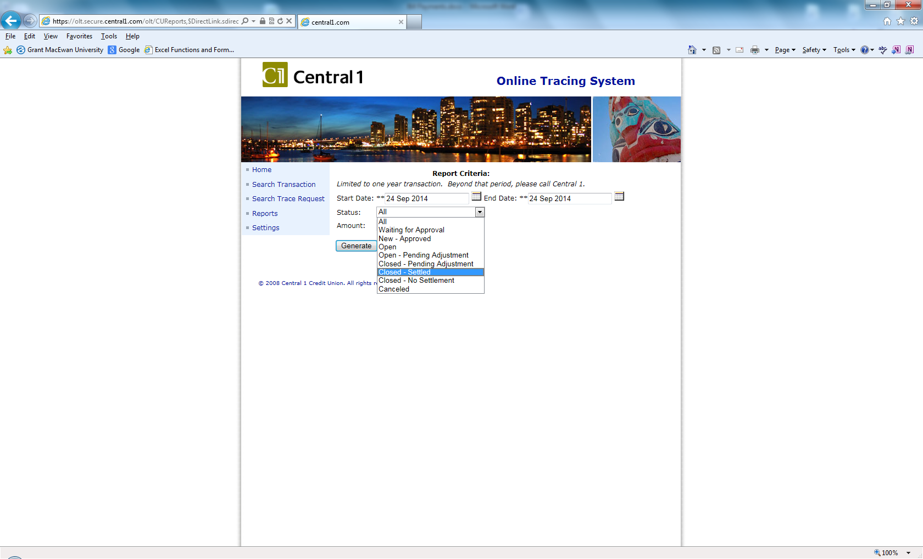

1. Once your criteria has been input 🡪 Select 🡪 

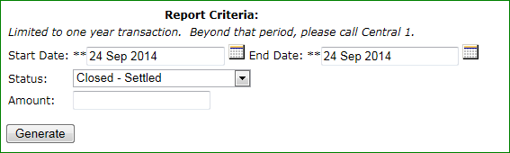

1. The following report will generate

* Each trace that has been settled will be listed individually
* Each trace will have an applicable service charge amount listed in the column to the right of the credit CWB will be receiving
* Only the value of the trace request will be credited to the CWB account
* The applicable service charges owing to Central 1 by CWB will not be charged to the CWB account 🡪 a separate invoice is sent from Central 1 and paid thru Accounts Payable.
* A CWB total will be located at the end of the report

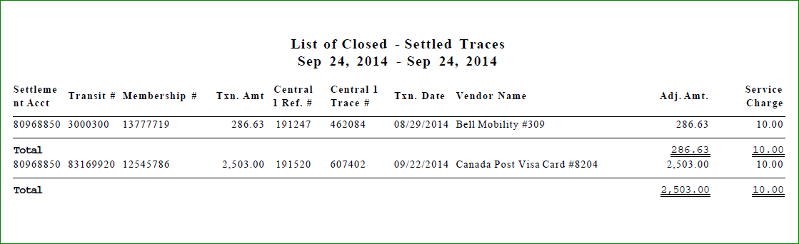

Transfer this info to the reconciliation

Individual trace details are listed in the top portion of the report





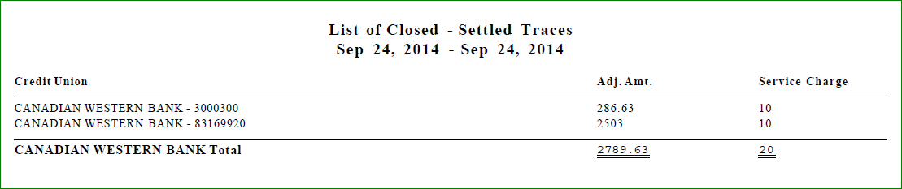

The total Adj Amt will equal the total amount credited to the CWB account

This portion of the report summarizes & totals all the traces for the date specified

1. Print the ***List of Closed – Settled Traces Report***
2. Match each individual item on the report with a trace request from the Outstanding Traces folder
3. Write the date the settlement was received on the front of the documentation
4. Transfer the individual trace details on to the reconciliation spreadsheet in the Purple section
   1. ***Central 1 – Bill Payment Account Statement Reconciliation*** 🡪 ***Detailed – Adjustment Transactions***

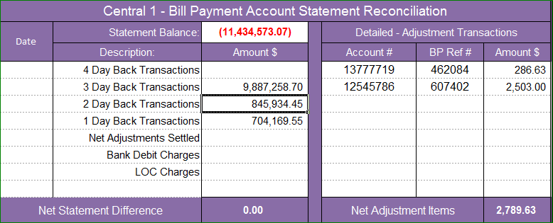

1. Add the data to the Posting Corrections for to credit the client
2. Move the item into the Completed Traces folder
3. Include the ***List of Closed – Settled Trace Report*** with your reconciliation documentation

## Vendor Initiated Traces / Returns

CWB is not informed prior to a vendor initiating a trace and returning a CWB’s client’s funds for a BP the vendor has rejected.

When funds have been received for a vendor return, a credit will be included within the Adjustment Amounts posted to the CWB account held at Central 1.

If there is an item listed in the List of Closed – Settled Traces report that cannot be matched with an outstanding trace initiated by CWB, then the details must be retrieved from the individual traces listed in the Inbox of the OLT – On Line Tracing Home page.

Return to the Home page 🡪 From the list of **. Closed – Settled Traces .** select the item whose Membership # and Trace # match the remaining unmatched item on the ***List of Closed – Settled Traces Report***

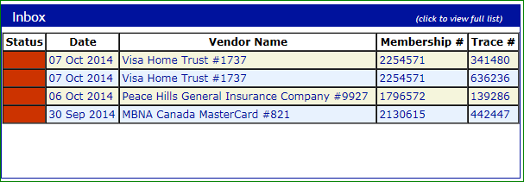

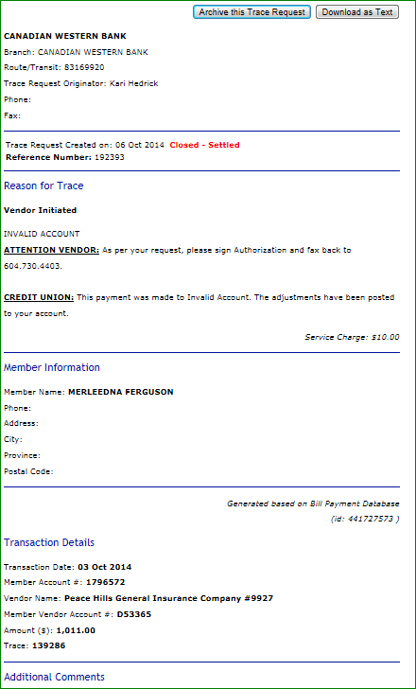

Your selection will bring up the details of the settled trace 🡪 select  for a report

The detailed report will have the necessary information to record and apply the credit to the client

In the **Reason for Trace** section of the report it will indicate that the item is a **Vendor Initiated Trace** and the reason for the return such as **Invalid Account**

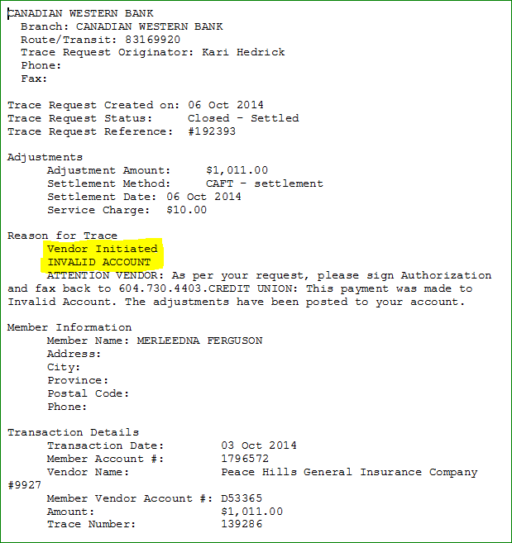

### Processing a Vendor Initiated Trace / Return

1. Print the detailed trace request report from the OLT – On Line Tracing website
2. Transfer the individual trace details on to the reconciliation spreadsheet in the Purple section
3. Print a screen shot of the BP transaction posted to the client’s account
4. On the Detailed Trace Request Report add the following information 🡪
   1. Client account type
   2. The client branch
   3. The amount of applicable service charges
5. Add the data to the Posting Corrections to credit the client
6. Notify the branch of the Vendor Initiated Return being sure to include a copy of the email sent to the branch with your reconciliation
7. Include the Vendor Initiated Return documentation with your reconciliation
8. Move the item into the Completed Traces folder after it has been verified

## Same Day Reversal

A Same Day Reversal is a trace request where a bill payment was initiated on the current day & the client wishes to cancel the payment on the same day.

***For example*** 🡪 a client initiates a BP in the amount of $1100.00 on Oct 10 at 11:00 AM. The BP is also processed thru the client’s account at 11:00 AM. At 11:15 AM the client realizes that the BP amount should have been $110.00. The client calls their branch representative at 11:17 AM of the ***same day*** to have the BP corrected.

***Bill Payments made to the CRA can only be recalled on the same day as they are initiated. If the payment has been made on a previous day, the trace / recall cannot be completed. Only Same Day Reversals can be completed on CRA Payments. In these cases, the client must deal directly with the CRA***



There is a time restriction on Same Day Reversals. CWB must contact Central 1 directly with a request to remove a BP item from the queue of payments scheduled for remittance therefore the client and the branch must allow CAP enough time to process the documents and contact Central 1. CAP must also make provision to allow sufficient time for Central 1 to process the request.

Central 1 must receive reversal requests by 4:00 PM PT (5:00 PM MT). ***Reversals are only processed Monday to Friday excluding statutory holidays.***

The following billers have a 2:00 PM PT (3:00PM MT) deadline:

650 Community Visa

3985 Citizen’s Bank Prepaid Visa

3936 Vancity Prepaid Visa

8204 Canada Post Visa Card

Payments made to the following Billers ***CANNOT*** be reversed:

28 Vancity Visa

274 Citizens Bank Visa

1008 Hyperwallet

In order to allow sufficient time for the Same Day Reversal process to be completed for all parties, the ***latest*** the branches should be contacting CAP is ***3:30 PM MT***. The deadline, however, is negotiable up to ***4:00 PM MT*** 🡪 depending on when the request is received from the branches circumstances may or may not allow for the processing of the request. The CAP admin must use good judgement and discretion on all requests received.

Bill Payment Same Day Reversals are completed online using the OLT Online Tracing URL: <https://www.secure.central1.com/Pages/Applications.aspx> using the ***Service Now*** application.

Regardless if the original communication with the branch was initiated by phone, the branch must send an email to the [CAPManagers@cwbank.com](mailto:CAPManagers@cwbank.com) (the branch can also CC the CAP admin) requesting the Same Day Reversal of the payment & providing the following details:

1. Client Account #
2. Date of BP
3. Amount of BP
4. Reference # of BP
5. Vendor of BP

If the branch has not already confirmed that the client agrees to pay the service charges that apply to traces, respond to the branch email to inform them that the client will be subject to a service charge. Ask the branch to confirm that the client agrees to the service charges & only continue with the trace if the branch / client have authorized CAP to proceed.

1. Once you have obtained approval from the branch / client, print the email to use this as your source document
2. Print a screen shot of the BP transaction posted to the client’s account
3. Complete the Same Day Reversal Request using the Online Request form

Access the OLT [Online Tracing URL](https://sts1.secure.central1.com/adfs/ls/?wa=wsignin1.0&wtrealm=https%3a%2f%2fgw1.secure.central1.com%2fInternalSite%2fADFSv2Sites%2fsecure&wctx=rm%3d0%26id%3dpassive%26ru%3d%252fInternalSite%252fADFSv2Sites%252fsecure%252fdefault.aspx%253fresource_id%253dA3200168563742E8A62E03AD70D0B3A8%2526login_type%253d2%2526site_name%253dsecure%2526secure%253d1%2526orig_url%253dhttps%253a%252f%252f172.19.24.40%252f%2526URLHASH%253df2a80d0d-0538-4196-ae08-615250dc7603&wct=2015-11-17T16%3a26%3a01Z&wreply=https%3a%2f%2fgw1.secure.central1.com%2fInternalSite%2fADFSv2Sites%2fsecure%2fDefault.aspx) 🡪 then select ***Service Now*** from the application options

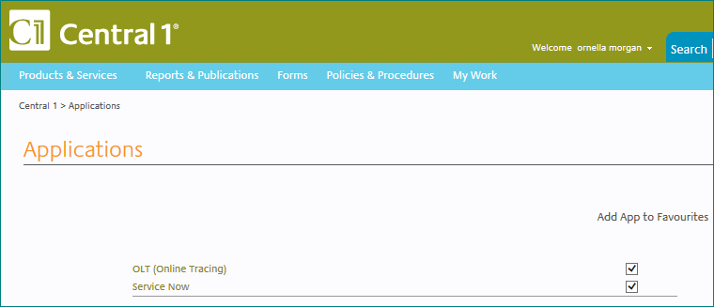 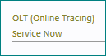

Once you have accessed Service Now, under Electronic Payments, select ***Bill Payment Reversal Request***

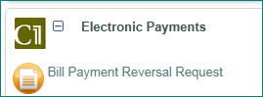

This selection will bring you to an online form 🡪 Complete all required fields on the form

* All mandatory fields are in pink (*)

***Transactional Information***

* *Trace Number
* *Biller Name
* *Biller Number - See Obtaining a Biller Number
* *Biller Account Number
* *Transaction Amount
* *Transaction Date
* Member Account Number (CWB Client account #)

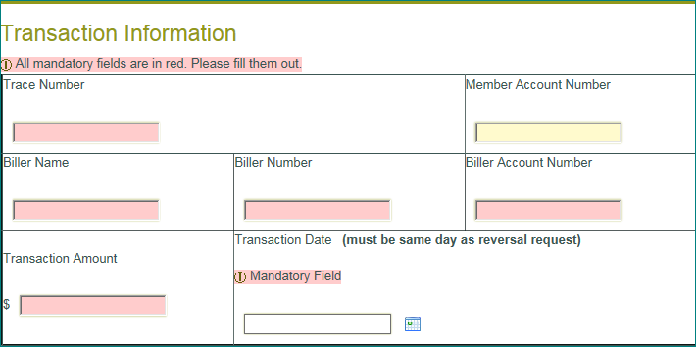

***Reason for Reversal Request***

* Select a reason from the drop down choices
* Enter the Branch Name as Canadian Western Bank
* Enter the Transit Number as 03019-030
* Provide any additional comments in the Comments field

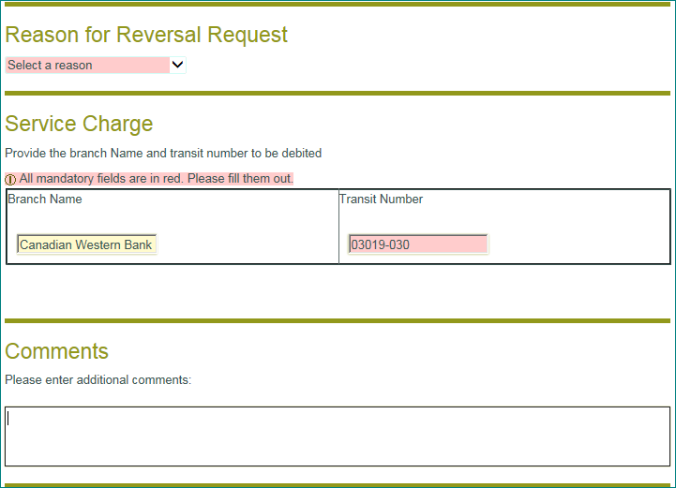

Double check your inputting, then Submit the form 🡪

Immediately after submitting the form, you will receive a **Ticket #** 🡪 make note of the ticket # on your email from the branch

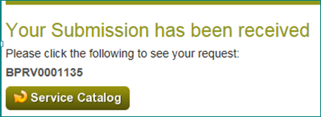

To print the Request Form 🡪 click on the ***Service Catalog*** button directly under the Ticket #

The following window will appear with all the details about the reversal request

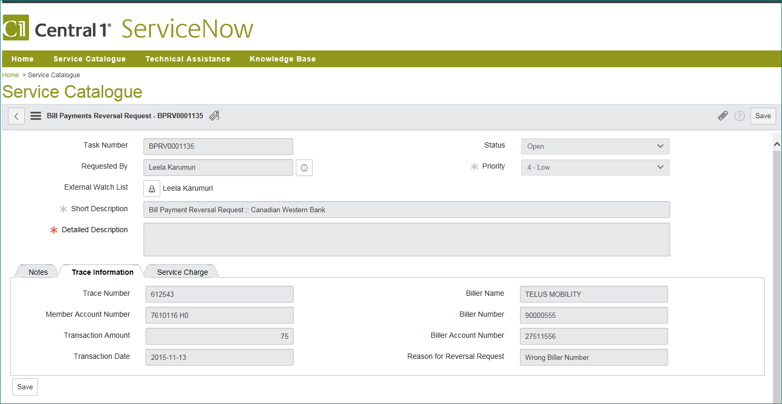

From the Menu Options in the header of the request details select 🡪 ***Export*** 🡪 ***PDF Portrait***

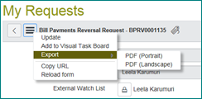

1. Print the completed form & immediately after
2. Gather & take the following documents to a supervisor for authorization
   1. Branch email request
   2. The account print out
   3. Completed Same Day Reversal Request Form
3. Central 1 will reply to the online submitted request via email to your own personal inbox. Look for the email to be received within 30 minutes of your original submission; however, it may take as long as 60 minutes for Central 1 to respond.

If you have not received an email within 60 minutes of your original submission, send an email to [bptrace@central1.com](mailto:bptrace@central1.com) to follow up with Central 1.

* 1. The email confirmation will provide a confirmation that the BP has been reversed from the scheduled remitted queue and will contain a confirmation number that will begin with the call letters **RV #**



* 1. Open the email and print the confirmation

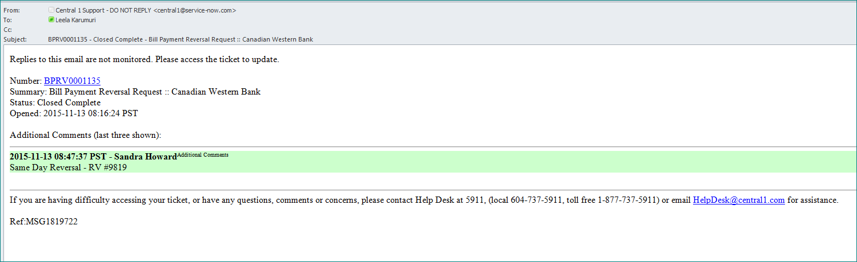

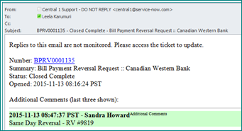

1. Record the confirmation # and the applicable service charges on the completed form
2. Once the confirmation from Central 1 has been received prepare and post the correction and service charges to the client’s account

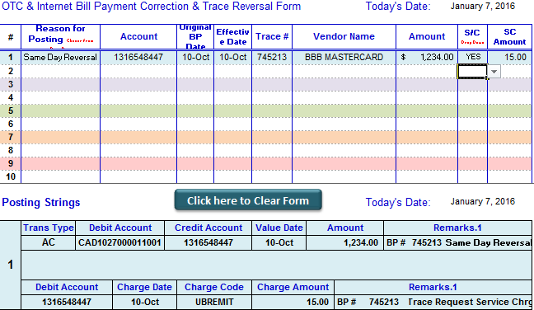

1. If the Same Day Reversal request was completed before the reconciliation was handed into a manager for verification then 🡪 include the Same Day Reversal with the rest of the reconciliation.
2. If the Same Day Reversal was processed after the reconciliation was verified then 🡪 file the trace in the Completed Traces folder once verified🡪 one copy of the posting correction will remain in your blotter.
3. On the following day, when reconciling, the BPRT report will list the BP as a reject with a description of **REVERSED BY USER** 🡪 see example below

CENTRAL1 10/08/14 BPRT 083169920 CENTRAL 1 CREDIT UNION PAGE: 130

BILL PAYMENTS - REJECTED TRANSACTIONS RUN DATE 10/09/14

CREDIT UNION 699 BRANCH 2 (CANADIAN WESTERN BAN) RUN TIME 00:48:32

==================================================================================================================================

MEMB.ACCT RE EXPLANATION VENDOR NAME VENDOR ACCT TXN TIME TXN AMT TRACE

02099737 94 POSSIBLE DUPLICATE TXN. TXN IGNORE VANCITY VISA 4789011101271654 15:35:30 50.00 391937

**08931537 6 REVERSED BY USER CRA GST 58 / RC159 817071947RT0001 01:31:59 3,000.00 704348**

* TOTAL NUMBER OF REJECTED ITEMS: 2 *

* TOTAL AMOUNT OF REJECTED ITEMS: 3,050.00 *

1. If Bill Payment Reversal Request is not available online, the manual procedure of completing the paper form will take precedence.
   1. Complete Form # 1793 – BP Same Day Reversal Request



The BP Same Day Reversal Request Form # 1793 can also be accessed in the following folder ***🡪 G:\Direct Pay\CENTRAL 1 FORMS***

***Filling out Form # 1793 – the Biller Number is still a Mandatory field***

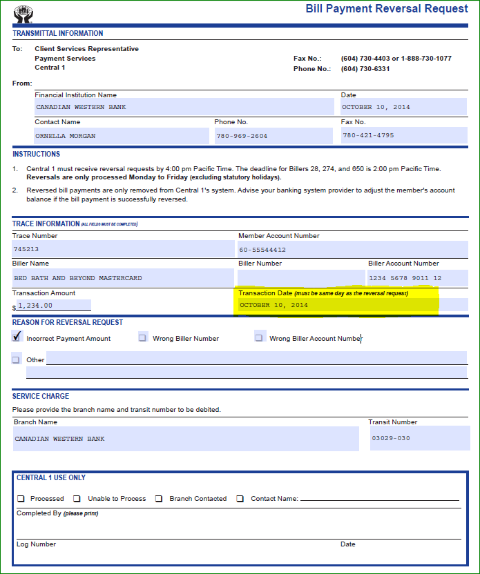

1. Scan & email the completed & authorized form #1793 to the following Central 1 email address 🡪 [bptrace@central1.com](mailto:bptrace@central1.com)
2. Central 1 will respond with the confirmation # (RV#) either by fax or email.
3. Continue following the procedures as outlined starting at step #7.

### Obtaining a Biller Number

As of September 2015, the Biller Number must be provided when completing a Same Day Reversal request. On the online request form Central 1 has made this a mandatory field.

Biller Numbers are not included in the posted information to the client account; to obtain the biller number Central 1 has provided their online Biller Listing 🡪 the listing can be accessed thru the following URL:

Online Billers Listing 🡪 <http://billers.central1.com>

1. Access the Biller Number Listing 🡪 the following window appears:

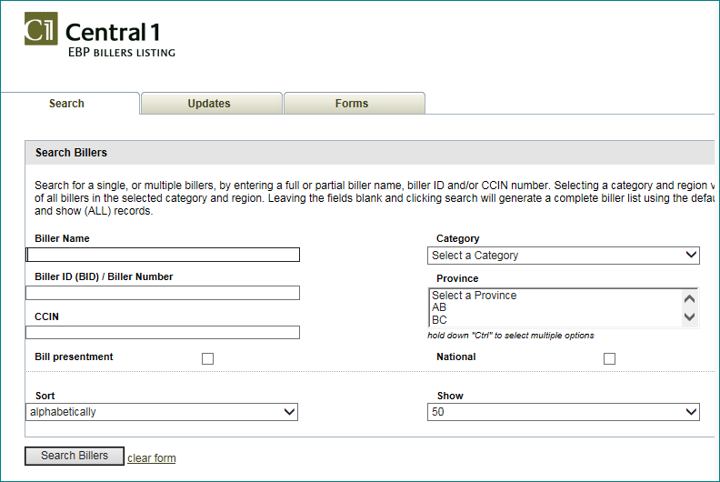

1. Enter the full or partial biller name, the category and the province 🡪 then select Search Billers

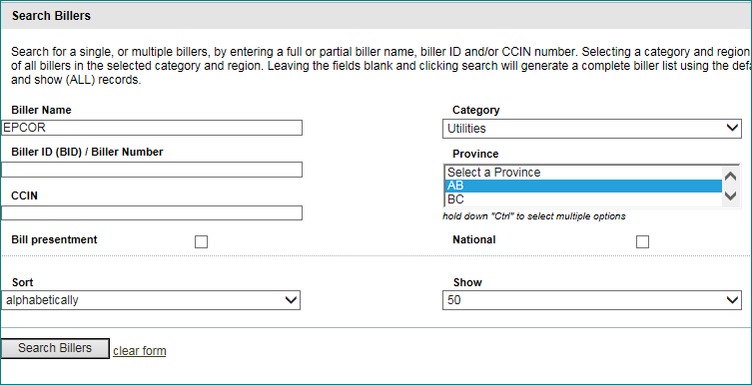

Results in 🡪 the CCIN # is the Biller Number – input this number on the Reversal Request form

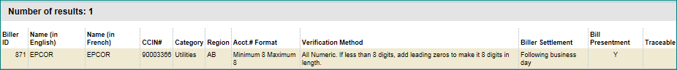



If there are multiple results showing, select the CCIN number whose account number format matches the format of the account on the client’s transaction.

# CWB VISA Bill Payment Traces

***\*\*This process applies to CWB Business Visa only – CWB MBNA traces are handled in the same manner as other vendors\*\****

## Overview

CWB offers Business credit cards (Visa) to incorporated companies, partnerships, sole proprietors, trusts and societies. Refer to Operations Manual F16 Business Credit Cards or Products and Services for Product information.

Each Visa Card type will start with the following numbers:

* Business Visa Gold (457288)
* Business Visa Platinum (472583)

The service provider for business credit cards is Fidelity Information Services (FIS). They provide payment data processing and ancillary services that include data storage, fraud management, Score Card Rewards program, card portfolio consulting services and a dedicated client care line. Centralized Services - Cash Management Support group works with FIS for payment processing.

## Process

### Online Payments Made at Other FI’s

* Clients are able to process online bill payments to credit their CWB Visa.
* The payment is debited from the client account and funds are remitted to CWB via an EDI file.
* The EDI file is received as a credit at CWB’s main operating account held at RBC.
* The EDI file is then processed by Cash Management Support.

There may be times when a client requests a recall of a Visa Payment made via internet banking.

* When the client requests the payment to be recalled the client is to contact their FI to request the recall.
* The request is then received in the Cash Management Support email.
* Cash Management Support will then advise FIS of the request.
* The Visa account will be amended and Cash Management Support will advise the requesting FI to debit the CWB account 7172 1013176 held at RBC → or CMS will send a Canadian Draft to the requesting FI for settlement.

### Online Payments made by CWB Clients Using CWB Direct

* When the request is received from a CWB Client where the payment was made on CWB Direct or CWB Direct Advanced or Business Online Banking and a CWB account was debited, the process at branch level will remain the same as all other bill payment recall requests:
* Client contacts their Branch to advise of the request.
* Branch contacts CAP to request payment recall → branch must provide all details of the transaction including:
* The date of the transaction
* The payment amount
* The card number
* The client name
* The client account #
* CAP acknowledges the request to the branch and advises of a 15.00 service charge.
* Instead of processing an On Line Trace Request, CAP will forward the branch email request to Cash Management Support at cash.management.support@cwbank.com to advise of the recall request.
* Cash Management Support will complete Authorization Form for Payment Recalls and attached branch email and any other supporting documentation.
* Once the CWB Visa account has been properly affected on the FIS system, Cash Management Support will post the following transactions:

1. Debit GL 14506 Br 1
2. Credit CAD1028200011001
3. Cash Management Support will advise the CAP Administration Officer initiating the recall request via email once the postings have been completed.

* CAP Deposits will process the following transactions:

1. Debit CAD1028200011001 then credit CWB Client Account

2. Debit CWB Client Account for 15.00 “TRACERECALL”🡪 See Job Aid “Charging AD-Hoc Charges”

3. CAP is to attach the Authorization Form for Payment Recall to both the client credit voucher and Bill Payment Trace request.

4. CAP will advise the branch once the postings to the client’s account are complete.

**Same day reversals are sent to Central 1 following normal procedures**

# Putting the Reconciliation Together

Once the reconciliation is completed, it must be verified by a supervisor. Organize the reconciliation documentation in the following order:

1. CWB Direct Bill Payments Reconciliation spreadsheet
2. CWB Direct Bill Payments Wire Settlement Form
3. CWB Central 1 account statement
4. GL 11019 BR 1 print out
5. GL 99989 Br 2 print out
6. Bill Payments Posted Not Remitted by Central 1 comparison report
7. Remitted Bill Payments Not Posted comparison report
8. BPRT report from BILLMMDD.dat report
9. BPRF report from BILLMMDD.dat report
10. BPFC report from BILLMMDD.dat report
11. All notification emails sent to the branches for BP rejects and Vendor Initiated Returns
12. Two (2) copies of the posting corrections form
13. All documentation for settled trace requests
14. A copy of the previous day’s CWB Direct Bill Payments Reconciliation spreadsheet 🡪 this copy is to aid the verifier in determining which reconciling items were

Once the reconciliation has been verified and returned, the CAP admin will 🡪

1. File the reconciliation
2. File the settled trace requests and vendor initiated returns in the Completed Traces folder
3. File one copy of the posting corrections form in the teller blotter
4. Discard the copy of the previous day’s CWB Direct Bill Payments Reconciliation spreadsheet

# BP Tracking Volumes

The CPA requires that Financial Institutions report the total number and the total dollar value of all BP transactions generated in a calendar year.

In order to ensure CWB is reporting accurate data to the CPA, the BP transactions are tracked on a daily basis.

1. The required information is gathered from the following reports🡪

* ***Bill Payments Remitted Not Posted report*** 🡪 ***Grand Totals***
* *Alternatively, the top green section of the reconciliation sheet can be used to gather both totals*

1. Open the ***BP Tracking Volumes*** spreadsheet located in 🡪 ***G:\Direct Pay\Tracking***
2. Enter the number of transactions for each day
3. Enter the dollar value of transactions for each day
4. Save & close the BP Volumes Tracking spreadsheet

***Example Using Grand Totals or Green Section of Reconciliation:***

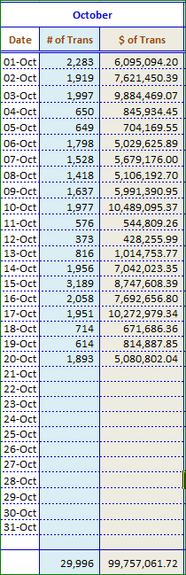

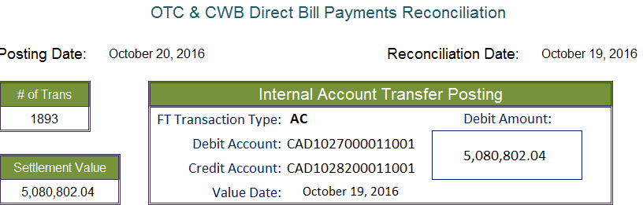

# Verifying Monthly Billing for Traces

On a monthly basis CWB is invoiced for all Closed & Settled Traces as well as all completed Same Day Reversals from the previous month. The traces consist of closed & settled CWB initiated as well as Vendor initiated items.

CAP Corp’s role in the invoicing process is to ensure that CWB is being charged for the correct # of trace and Same Day Reversal items by matching the items listed on the different reports to the documentation maintained by the admin for completed traces.

Central 1 will send CWB CAP Corp department the monthly charges report via fax

The Billing reports are usually received by the 2nd or 3rd business day of each month

There are three different reports 🡪

1. ***Monthly Charge Report***
   * Summarizes all charges for # of items processed & # of traces & same day reversals processed
2. ***List of Closed – Settled Traces*** 
   * Summary of Charges by***CWB initiated & Vendor Initiated***
   * Details by Trace of Charges one each for***CWB initiated & Vendor initiated***traces
3. ***Service Charge Log 🡪*** *this report is manually generated by Central 1*
   * Lists in detail each Same Day Reversal processed for the month

## Verifying & Matching Charges

1. ***Monthly Charge Report***
   * Ensure the total charges listed under Photo Retrieval equal the charges for the closed & settled traces plus the charges for the same day reversals
2. ***List of Closed – Settled Traces*** 
   * ***CWB Initiated Trace Charges & Vendor Initiated Trace Charges***
   * Using the detailed List of Closed – Settled Traces match each individual charge to documentation maintained by the admin & filed in the Completed Traces folder
   * The match can be completed using the OLT Ref #, or the Trace #, or the Vendor Name & Trans Amt or any combination of these fields
3. ***Service Charge Log***
   * ***Same Day Reversals Charges***
   * *Using the Reference # column, match each* individual charge to documentation maintained by the admin & filed in the Completed Traces folder
   * *The match must be completed using the Ref # as this is unique to the same day reversal processed & should be recorded on the documentation maintained by the admin*

There may be 1 or 2 completed traces in the Completed Traces folder that do not match to any charges on the current billing 🡪 these items are left over. If the trace took place late in the month, there is a possibility that the item will be included with the following month’s charges. Leave these remaining documents in the completed trace folder until the next report comes in. If the item has not been charged by the following month, remove it from the folder and add it to the current month’s billing with a notation stating ***“Not Charged”.***

Occasionally, there will be completed traces charged that do not match to any documentation. This may be due to incorrect details reported on the billing report.

If there is a trace item that was never charged by Central 1 or if there is an item charged by Central 1 that has no documentation, it is not necessary to investigate these discrepancies because the errors are rare and the amounts are small. However, if the discrepancy (or discrepancies) is significant, bring the issue to a manager’s attention in order to determine course of action.

Gather all matched documentation & bundle according to the associated billing report from Central 1. Once bundled, the billing is filed in the box labeled **“DIRECT PAY TRACESINVESTIGATIONS”.** Retention for the report is 10 years.

## Extracting the Monthly List of Closed – Settled Traces

Even though Central 1 faxes the List of Closed – Settled Traces report to CAP Corp, it can be retrieved by an admin using the OLT Tracing Website.

Access & log into the OLT Tracing website 🡪 <https://www.secure.central1.com/Pages/Applications.aspx>

1. 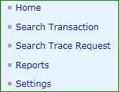From the navigation menu 🡪 choose Reports

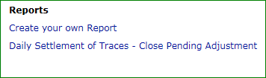

1. Choose 🡪 Create Your Own Report

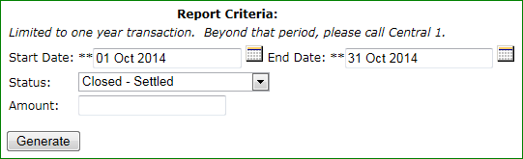

1. Input the Report Criteria 🡪

* Start & End Dates = Previous Month
* Status = Closed – Settled
* Select the Generate Button

The resulting report will show the same details as the reports faxed by Central 1 to CAP Corp for that month.

The report does not included Same Day Reversal traces or charges

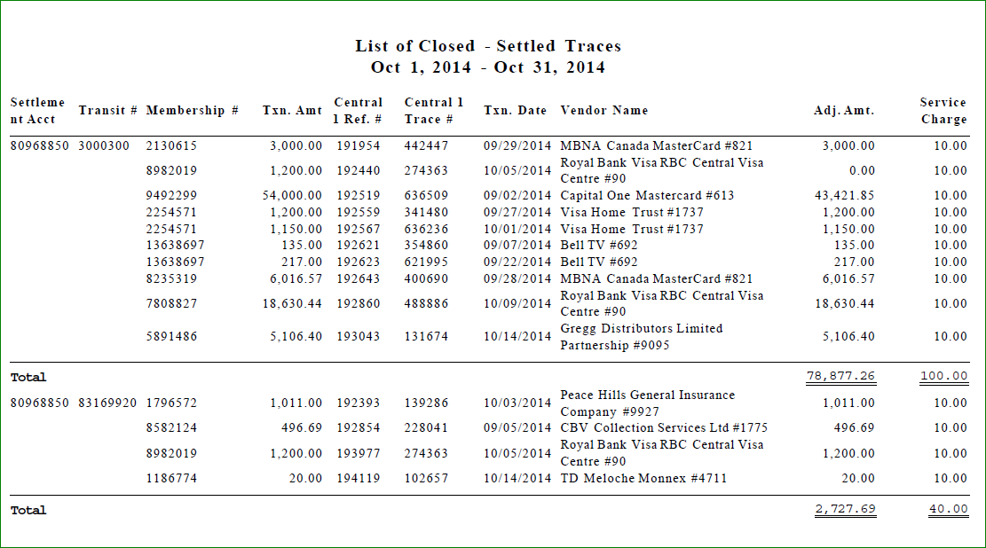***Example of Monthly List of Closed – Settled Traces generated using the OLT Tracing Website***

## Sample Reports

### Monthly Charge Report

Example of Monthly Billing received via fax from Central 1

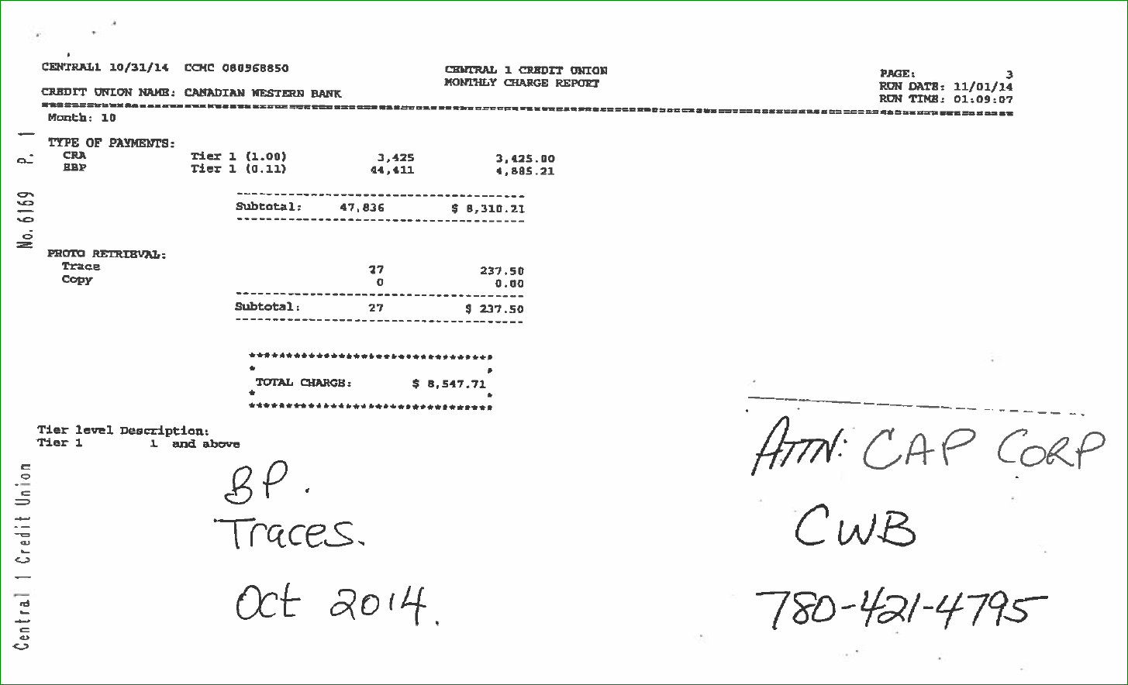

### List of Closed – Settled Traces 🡪 CWB Initiated & Vendor Initiated Billing Summary

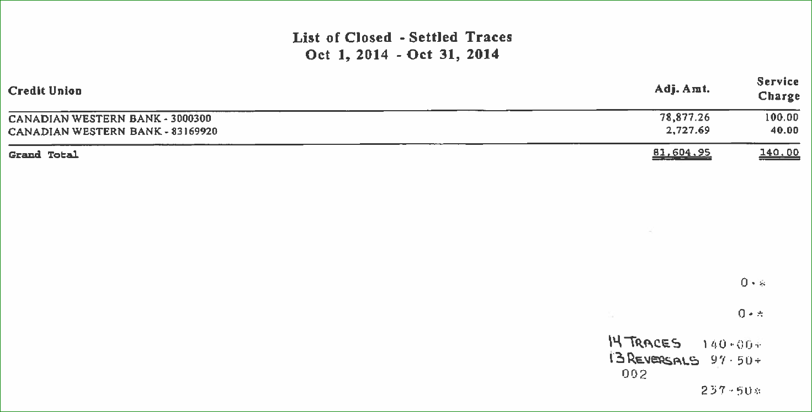

### Details by Trace – CWB Initiated

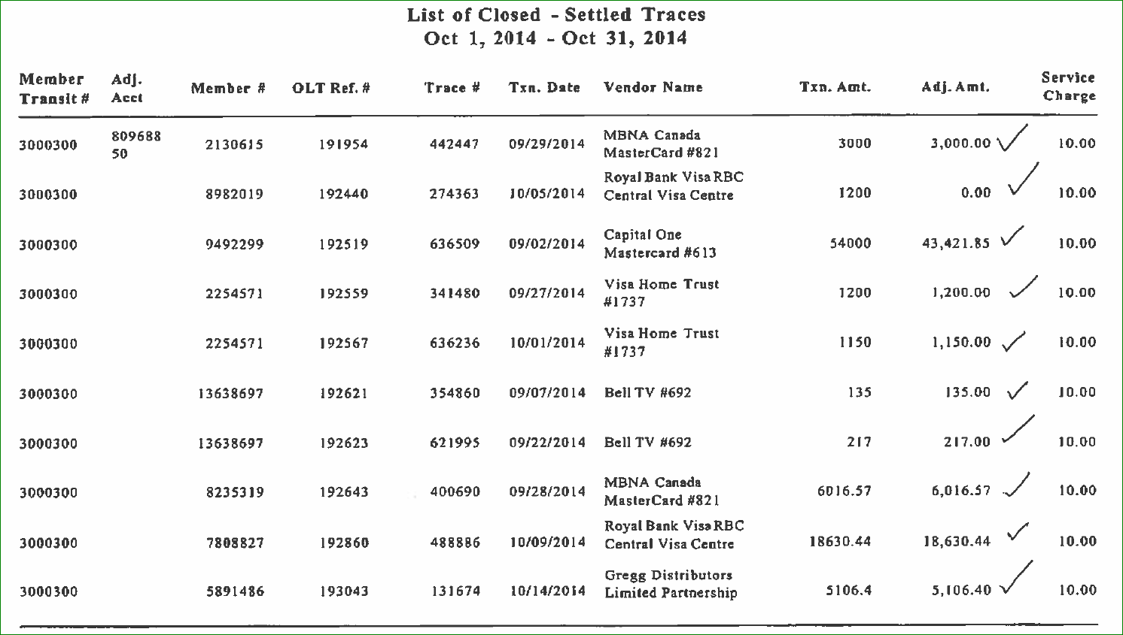



### Details by Trace – Vendor Initiated

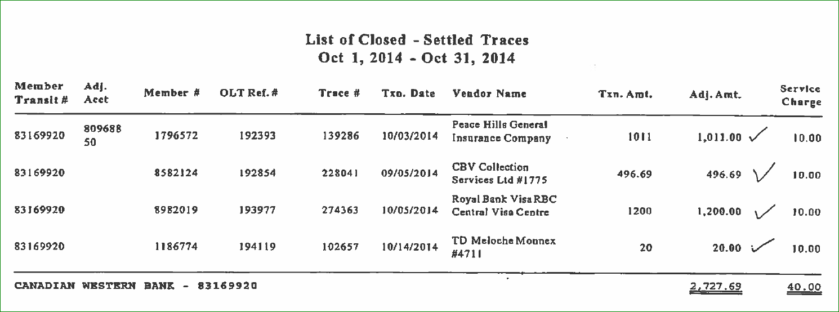

### Service Charges Log – Same Day Reversals

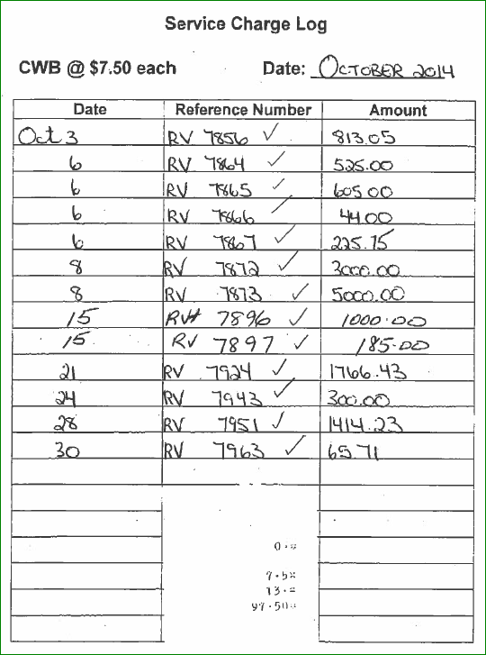

# Summary of Bill Payment Settlement & Reconciliation Process

## Part A – Report Gathering

1. Download reports from FTP site 🡪 move the reports from the right panel (Central 1) to the left panel (G Drive)
2. Save reports on to: **G : \ Direct Pay \ BC Central Reports \ Year \ Month**
3. From the Direct Pay folder on the G Drive open each report separately & save on to: **N: \ MISCommon \ Day of Week (Monthend)** 🡪 **save as directpay.txt**
4. **From the BILLMMDD.DAT** print the following reports:

* **BPRT**
* **BPRF**
* **BPFC**

1. Open the **CUCBC Access Program** 🡪 Run the program to produce the comparison extracts:
2. Select the day of the week from the drop box & print the resulting reports

* On Direct Pay Not on Report 1
* On Report 1 Not on Direct Pay

1. Obtain 2 copies of the Central 1 BP Account statement from a Managers
2. Obtain the previous day’s reconciliation

## Part B – Verifying Statement Details

1. Ensure the previous day’s wire settlement was received & credited to the BP account & the account balance was brought to the current float value
2. Review the account closing balance 🡪 it should be equal to the Grand Total amount on the ***Remitted Bill Payments Not Posted*** report plus the current float value
   1. If yes 🡪 then the correct files were imported 🡪 continue with settlement & reconciliation
   2. If No 🡪 then check for 🡪
      1. Any credit adjustments for traces posted to the statement
   * If yes, then pull the details from the OLT Tracing system 🡪 then continue with settlement & reconciliation
     1. Any service charges or interest fees posted to the statement
   * If yes, then include the amounts when settling & reconciling
     1. Were the correct files imported into the CUCBC Access program?
   * If yes, & the amounts still do not match, then consult a supervisor
   * If not, then check to see the directpay.txt file is present and named correctly in the correct weekday folder in N: \ MISCommon and
   * If not, then check to see that the report1.txt file was updated to reflect the correct data

## Part C – Wire Settlement

*Green & Purple Sections:

1. Open the settlement & reconciliation spreadsheet 🡪 ***Central 1 Reconciliation – Direct Pay***
2. Use tab one **- Direct Pay**
3. Enter the reconciliation Date
4. Enter the # of transactions
5. Enter the value of the BP settlement 🡪 use the Grand Total from Remitted Payments Not Posted report
6. Post the daily BP settlement transaction 🡪 Use the posting string on reconciliation sheet
7. Enter the closing balance As IS on the Account statement 🡪 Statement Balance
8. Reconcile the statement:
   1. Left purple Section – Daily Settlements:
      1. Enter the transaction date
      2. Enter the Description from the drop box 🡪 1 day back, 2 days back etc.
      3. You will have more than 1 entry on Mondays, long weekends and after stat holidays
   2. Enter the value of the transaction(s) 🡪 use the Grand Total from Remitted Payments Not Posted report
   3. Right purple Section – Settled Trace Adjustments:
   4. Settled trace adjustments 🡪 shown as credits on the Statement & details established in Part B step 2
      1. Enter the CWB account # from the details retrieved from the OLT Tracing system
      2. Enter the BP Ref #
      3. Enter the value of the transaction
   5. Continue adding Daily Settlements & / or Settled Trace Adjustment details until the statement reconciliation comes to zero
9. Use tab two - Wire Settlement BP wire has to be ready before 9:30 a.m.
   1. Print the Wire Settlement spreadsheet – there will be 2 copies
   2. Post the BP wire settlement as indicated 🡪 use the posting string is on settlement sheet
   3. List the wire on the Outgoing Wire Tracking Sheet
   4. Create the wire on RBC Express using MT202 Central 1 – BP template
   5. Provide a print out of the wire, the statement, & the wire settlement spreadsheet to a supervisor for verification, authorization & release

## Part D – Reconciling the GL’s

Blue Section:

1. Print ***CAD1028200011001***
2. Print ***CAD1027000011001***
3. ***Reconcile CAD1028200011001*** – Left columns
   1. Enter GL Balance as is
   2. Wire amount sent to Central 1 will already be listed
   3. List the reconciling entries to come to zero use the Grand Total from ***Remitted Payments Not Posted*** report
      1. 1 Day Back Transactions (etc.)
      2. Settled Traces – lump sum 🡪 use the total of the Settled Trace Adjustments
      3. Other charges such as interest or service charges
4. ***Reconcile CAD1027000011001 –*** Right columns
   1. Enter GL Balance as is
   2. From the ***Remitted Payments Not Posted*** report enter the total value of BP’s not posted 🡪 amount is listed at far right side of report
   3. List the individual details of the rejects from the **BPRT** report
5. From the ***Bill Payments Posted Not on Central 1*** report list the individual details of the BP’s posted but were not remitted by Central 1 🡪 from the drop down box select ***Delayed Remittance***
6. Ensure items from previous day’s reconciliation that were listed as a ***Delayed Remittance*** are now remitted
   1. If yes, then change their status to Now Remitted
   2. If no, investigate, apply the correct status and correct the posting if required
7. Review all the BP records on the Remitted Bill Payments Not Posted report for an anomaly in the remitted time
8. Ensure all items with a remitted time that is not within the parameters of the overnight rights-off process are either:
   1. Posted on a previous day and represent a Delayed Remittance OR
   2. Posted on the current day
      1. If the review of the BP’s results in the discovery of an BP that was never posted 🡪 ensure the item is posted as soon as possible
9. Print Reconciliation

## Part E – Rejected Transactions

1. Notify the branches of the clients’ whose transactions rejected
   1. Rejects from the **BPRT** report
   2. Rejects from the **BPRF** report
2. Copy and paste the details of the 2 reject reports to a blank Word document
3. Add the branch #’s of the client accounts at the end of each transaction
4. Save the document on to your desktop or appropriate folder
5. Prepare an email including at least 2 contacts for the branches concerned using pre-selected verbiage associated with the reject type
6. CC yourself
7. Attach the detailed rejects report to the email
8. Send the email
9. Print a copy of the sent email for the reconciliation
10. **Tab Three – Correction Form** 
    1. Enter the required information for each reject on the **BPRT** report 🡪 these are the items that were listed on the reconciliation in order to balance GL 99989 Br 2
    2. Enter the required information for each individual settled trace adjustment (if any) 🡪 these are the items that were settled by C1 & credited to the BP account
    3. Enter the required information for each individual ***Same Day Reversal BP***
    4. Enter the required information for each individual BP that did not post as discovered when reviewing the BP’s on the Remitted Bill Payments Not Posted report
    5. Post each resulting transaction including the quotations provided
    6. Print Corrections Form 🡪 there will be 2 copies (1 = blotter – 1 = reconciliation)

## Part F – Tracking

1. Open the tracking sheet located at 🡪 ***G:\Direct Pay\Tracking \ BP Tracking Volumes***
2. Enter the # of transactions for each day reconciled
3. Enter the total $ value for each day reconciled

## Part G – Putting the Reconciliation Together

1. Reconciliation tab – Direct Pay
2. Statement
3. Wire settlement tab – Wire settlement
4. Remitted Bill Payments Not Posted report
5. Bill Payments Posted Not Remitted by Central 1 report
6. BPRT
7. BPRF
8. BPFC
9. Email Notification to branches
10. Posting tab – Corrections Form
11. Any Settled Trace Adjustment details

# FAQ’s- Miscellaneous Problem Solving

## Further Explanations of System Issues

* There may be times when there are problems balancing CWB Direct due to CWB Direct Bill payments not posting to the account.
* The issue may be caused by Central 1 in BC completing enhancements on Direct Pay or Central 1 and/or CWB is in rights-off and processing of the day’s transactions.
* The errors can occur when a client in a time zone **east of BC** makes a bill payment **CWB Times between 10:30-midnight Alberta Time.**
* The issue is CWB’s System and Central 1’s System are not communicating properly

**Effect 🡪** Central 1would receive requests from our clients for bill payments to the vendors but CWB system does not receive a message from Central 1 for the request of payment. The bill payments would post to the Vendor via Central 1 but the CWB client account was not debited.

CAP would not know that a payment was not debited to CWB Client until balancing process of the next day’s transactions.

**For example 🡪**

**Day 1**

Tuesday April 28 CWB client selects bills to be processed at 00:05 am

Tuesday April 28 @ 23:06 am Central 1 received payment request

**Day 2**

Wednesday April 29 Vendor received payment

Wednesday April 29 for April 28 CAP balances CWB Direct - debit to CWB client not processed at this time but does not show on balancing as it is included in a lump sum of items "not on report 1"

**CAP Administration Officers are to verify on T24 any items reported as remitted with a time prior to 10:00pm or 22:00 hours that the item has been posted to the client's account with the ACZP source code and matching trace number.**

**Day 3**

Thursday April 30 CAP balances CWB Direct and realizes that CWB client needs to be debited. CAP posts debit to clients account.

***Risk 🡪*** CWB Client Account has not been debited but funds have been remitted to the Biller/Vendor. Funds could be gone before the debit for the bill payment is processed against the account.

**Notification of Problems**

If more than one client is affected **CAP is to contact the CWB Help Desk.** CAP is to verify with the Help Desk if Central 1 had any system upgrades in the past 5 days. CAP is to stress that the non-posting of transactions on HOBS be escalated to the proper departments within Information Services as there is a risk to the Bank and Clients.



### Examples of Delayed Remittance Vendors

* Vancity VISA
* Canada Post VISA
* Citizen’s Bank VISA

## Alternate Report Options

If the statement is not available or up-to-date, the totals from each separate **BILLMMDD.dat** report can be used in its place 🡪 ***BPRS – Bill Payments Remitted Summary***.

If the Report1.txt required from BI to complete the comparison process that generates the Remitted Bill Payments Not Posted via the CUCBC Access program is unavailable or delayed, the totals from each separate **BILLMMDD.dat** report can be used in its place 🡪 ***BPRS – Bill Payments Remitted Summary.***

If the ***BILLMMDD.dat*** report is unavailable or delayed, settlement can be based on the statement alone provided all settlement amounts for all days outstanding have been posted to the account.

If all of the required reporting is unavailable, then consult with a supervisor in order to determine the best course of action.

## Trouble Shooting Issues

|  |  |
| --- | --- |
| Issue | Trouble Shooting Solution |
| The C1 account statement is not up to date with all the settlement transactions posted to the account | * Use the BPRS Summary Report from the BILMMDD.dat report to retrieve required totals |
| It is late in the morning & the Report 1.txt has not been updated by BI | * Have a manager create a Helpdesk ticket to advise BI that the report requires updating |
| The comparison reports generated from the CUCBC Access program each have an excessive amount of pages | * Check to see if the Report1.txt file has been updated 🡪 it might be too early to generate the comparison reports because BI has not been given a chance to update everything🡪 if this is the case, just wait a while longer * If it is late in the morning & the report1.txt file still is not updated, have a manager create a Helpdesk ticket * Check to ensure the BILLMMDD.dat file was saved into the correct folder and that it was correctly named 🡪 directpay.txt |
| The C1 account statement is available but the BILLMMDD is not available for download or it contains incomplete or corrupt data | * If the BILLDDMM report is not available, only the settlement portion of the process can be completed. Use the account statement to determine settlement. Reconciliation may need to take place later in the day 🡪 consult with a manager |
| CAD1028200011001 does not balance | * Review the values input into the spreadsheet * Review the postings for both the transfer & wire settlement * Are there any Net Adjustments Settled on the stmt that are now reconciling items * Are there any posting errors from a previous day * Are there any LOC Charges posted to the stmt that are now reconciling items * Are there any Bank Charges posted to the stmt that are now reconciling items |
| CAD1027000011001 does not balance | * Review the values input into the spreadsheet * Ensure all items listed from the BPRT as a reject were posted 🡪 there are times when C1 will report a reject on the BPRT report, however, the banking system will not have posted the rejected item or the banking system posted the rejected item but did not post the original item * Check all rejected items to ensure the original item as well as the rejected item were posted by the banking system 🡪 see further explanations in the topic called Comparison Reports Things You Need to Know sections for Remitted by C1 Not Posted & for BP Posted Not Remitted by C1 reports * Review any posting corrections completed for today or yesterday affecting GL 99989 Br 2 * Are there any posting errors from a previous day |

## Central 1 Contacts

|  |  |  |  |  |  |
| --- | --- | --- | --- | --- | --- |
| Description | Department / Name | Phone Number | Fax Number | | Email |
| Bill Payments Traces Same Day Reversals | Client Payment Services | 1-604-730-6331 | 1-604-730-4403  1-888-730-1077 | | [bptrace@central1.com](mailto:bptrace@central1.com) |
| Bill Payment Traces  Standard Traces | Standard Traces are to be completed using the  ***OLT On Line Tracing URL*** | | | | [OLT – On Line Tracing URL](https://sts1.secure.central1.com/adfs/ls/?wa=wsignin1.0&wtrealm=https%3a%2f%2fgw1.secure.central1.com%2fInternalSite%2fADFSv2Sites%2fsecure&wctx=rm%3d0%26id%3dpassive%26ru%3d%252fInternalSite%252fADFSv2Sites%252fsecure%252fdefault.aspx%253fresource_id%253dA3200168563742E8A62E03AD70D0B3A8%2526login_type%253d2%2526site_name%253dsecure%2526secure%253d1%2526orig_url%253dhttps%253a%252f%252f172.19.24.10%252fPages%252fApplications.aspx%2526URLHASH%253d82a1fdee-6bdb-48d9-bdf5-d441d65969d8&wct=2014-10-14T21%3a31%3a14Z&wreply=https%3a%2f%2fgw1.secure.central1.com%2fInternalSite%2fADFSv2Sites%2fsecure%2fDefault.aspx) |
| Wire Settlement | Funds Transfer | 1-888-889-7878  Option 1 |  | | [Fundstransfer@central1.com](mailto:Fundstransfer@central1.com) |
| Wire Settlement | Wire Department | 1-604-737-5040 |  | |  |
| Central 1 Reporting Issues | Client Support | 1-888-889-7878  Option 1  1-877-762-5252 | 1-855-772-9636  1-604-730-4438 | | [MemberDirect_Support@Central1.com](mailto:MemberDirect_Support@Central1.com) |
| Central 1 Transaction Issues | Client Support | 1-888-889-7878  Option 2 | | 1-855-772-9636 | [MemberDirect_Support@Central1.com](mailto:MemberDirect_Support@Central1.com) |
| Online service option – for inquiries / issues | Client Support | CWB User must be given access to Central 1 Service Now | | | <https://central1.service-now.com> |
| CWB Client Technical Issues | CWB Helpdesk | Refer the branch to Helpdesk | | |  |
| All other CWB Client Issues | CAP Deposits | 780-423-9744 |  | | [CAPManagers@CWBank.com](mailto:CAPManagers@CWBank.com) |
| Manager, Central 1 Support | Jason Seale | 1-800-661-8901  Ext 5185 |  | | [jseale@central1.com](mailto:jseale@central1.com) |
| Client Success Executive | Kari Johnson | 1-604-730-5106  or  1-800-661-6813  Ext 5106 |  | | [kjohnson@central1.com](mailto:kjohnson@central1.com) |
| Director, Strategic Relationships | Peter Kellett | 1-800-661-6813  Ext 5164 |  | | [pkellett@central1.com](mailto:pkellett@central1.com) |